1. Screen header/title name display mismatch content//
2. Column header name not display in the middle of the column//
3. Deleted record display in list grid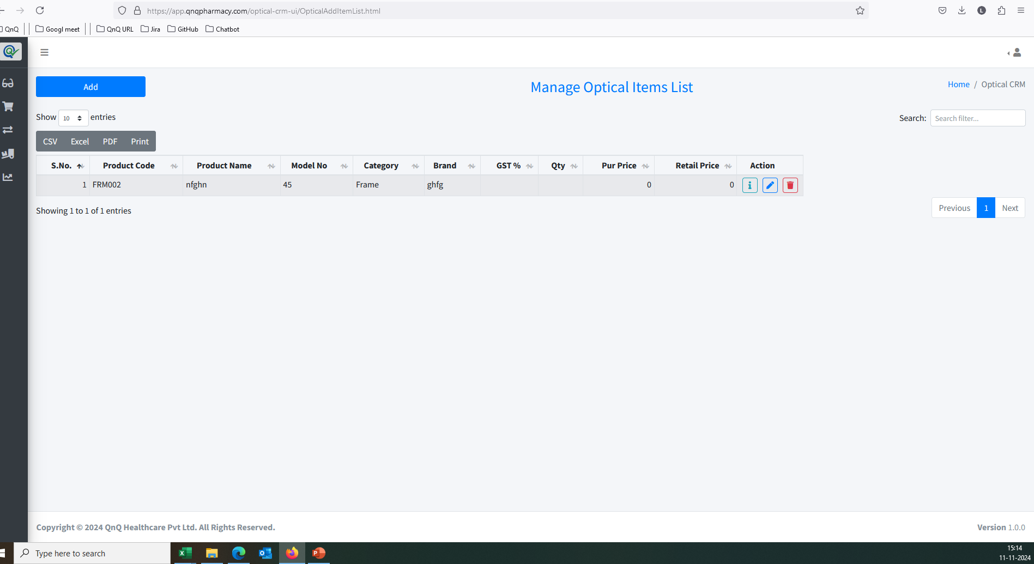 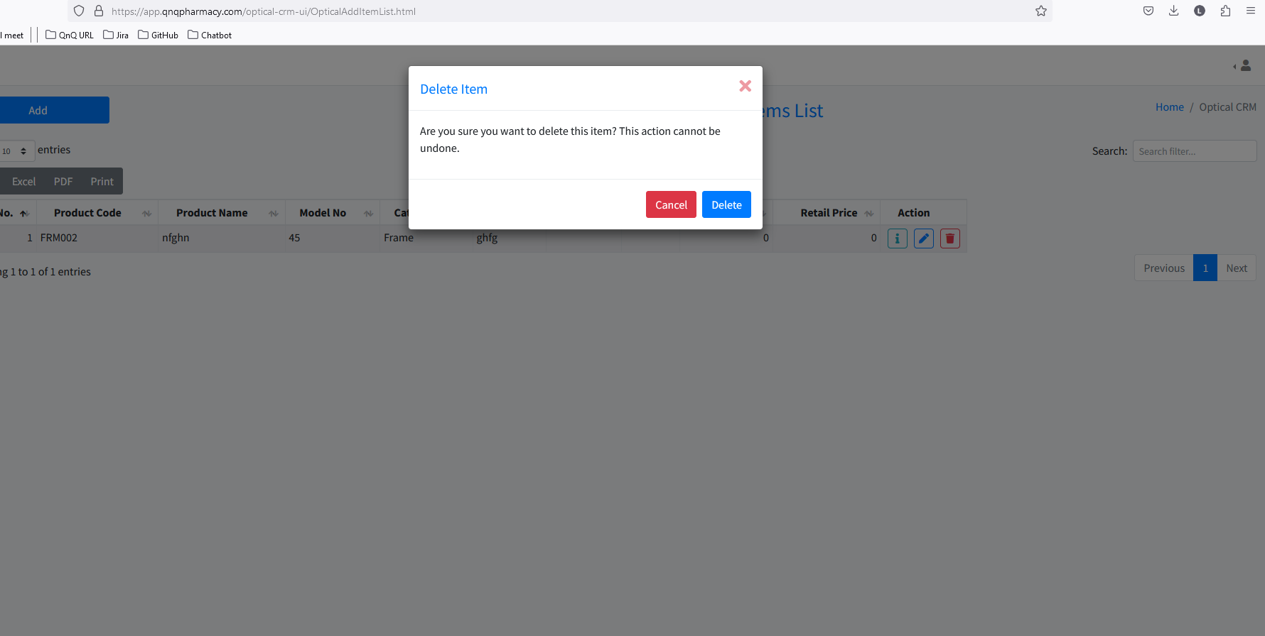//
4. Column Header, Search filter and Pagination not display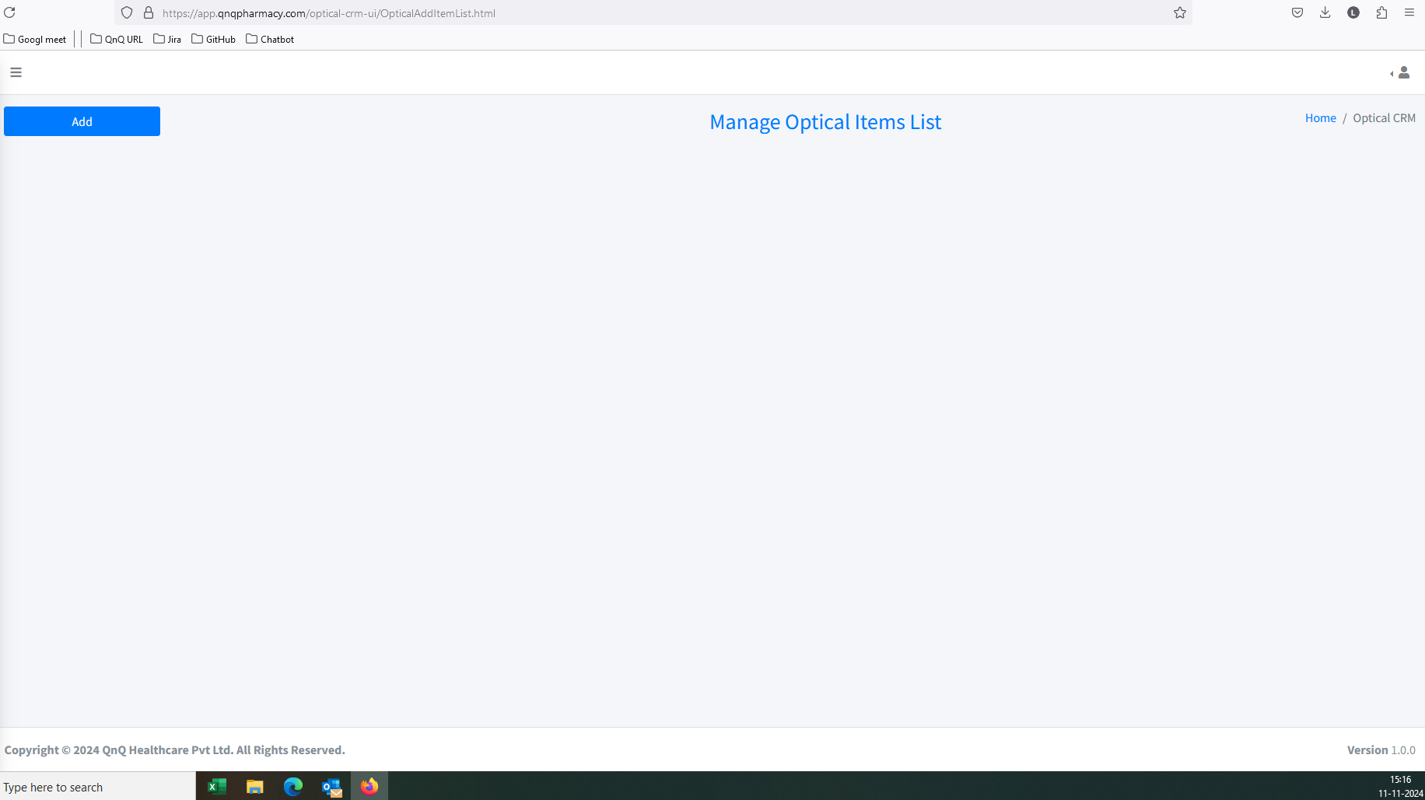//
5. No record available message not display in list grid//
6. Unwanted page getting redirect while click Home button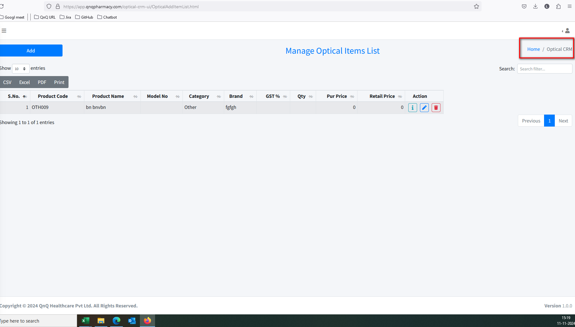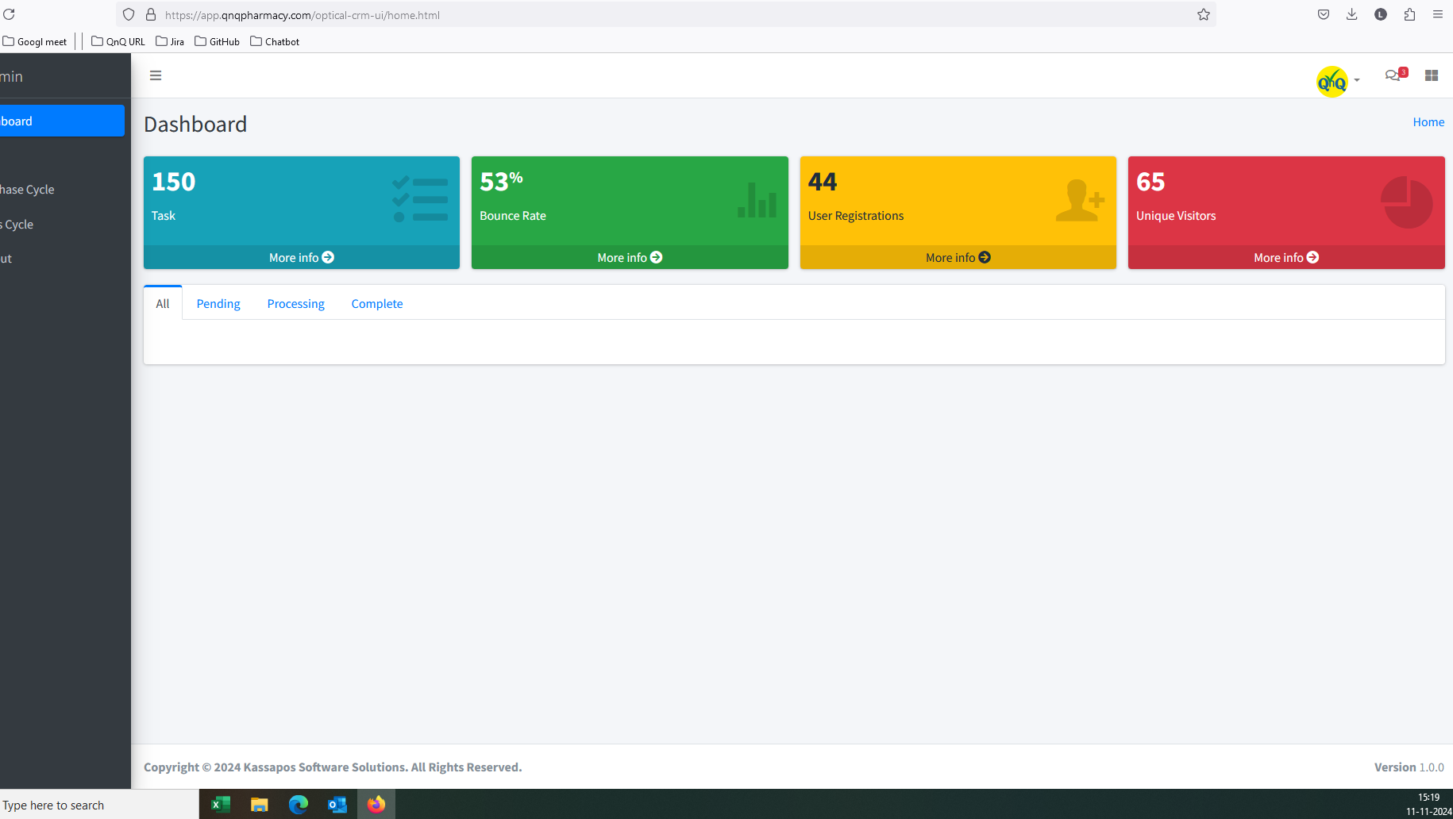//
7. Improper alignment display in list grid 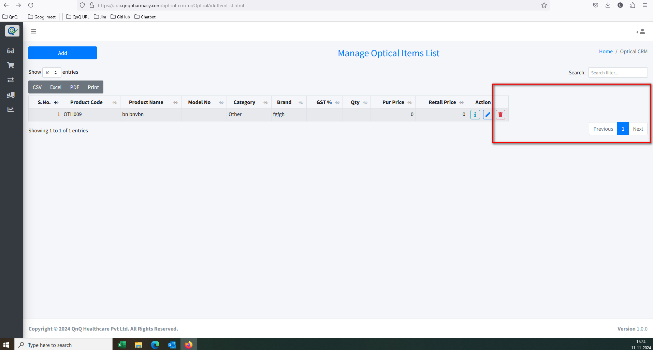 //
8. Mismatch name display in add New button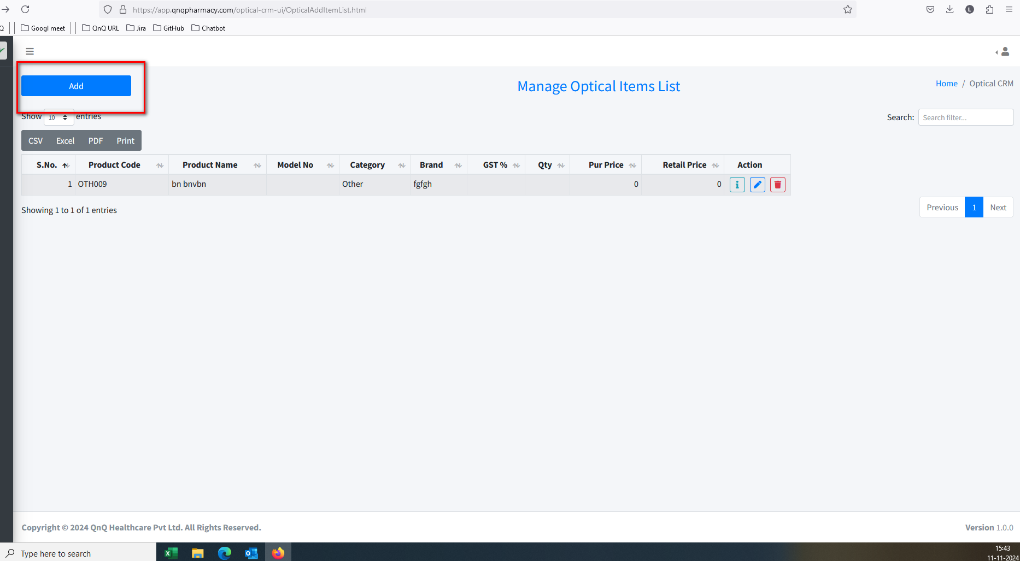 //
9. Unwanted column display in list grid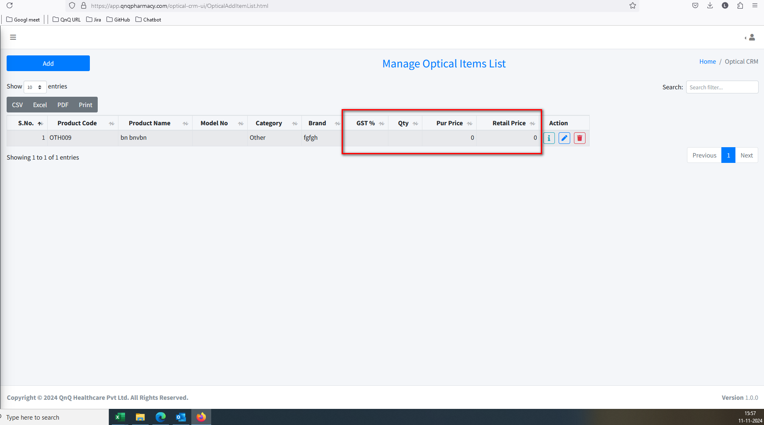 //
10. Confirmation message display while click close button without change any value 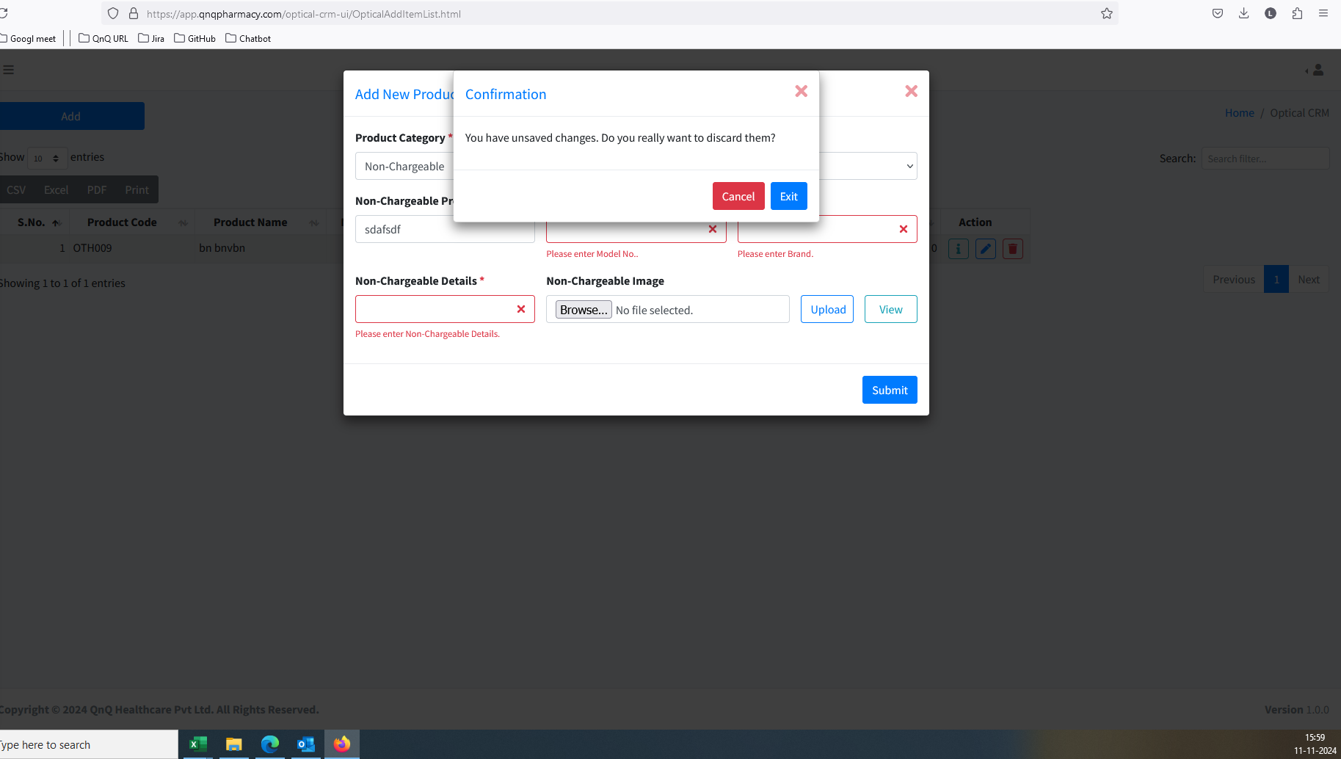 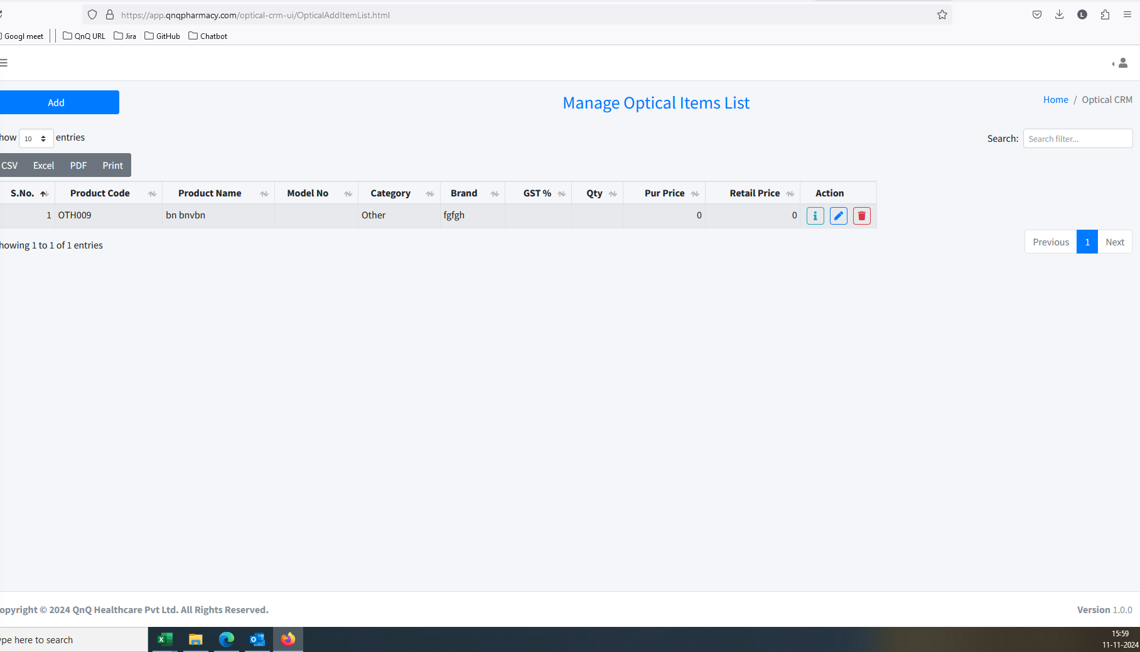 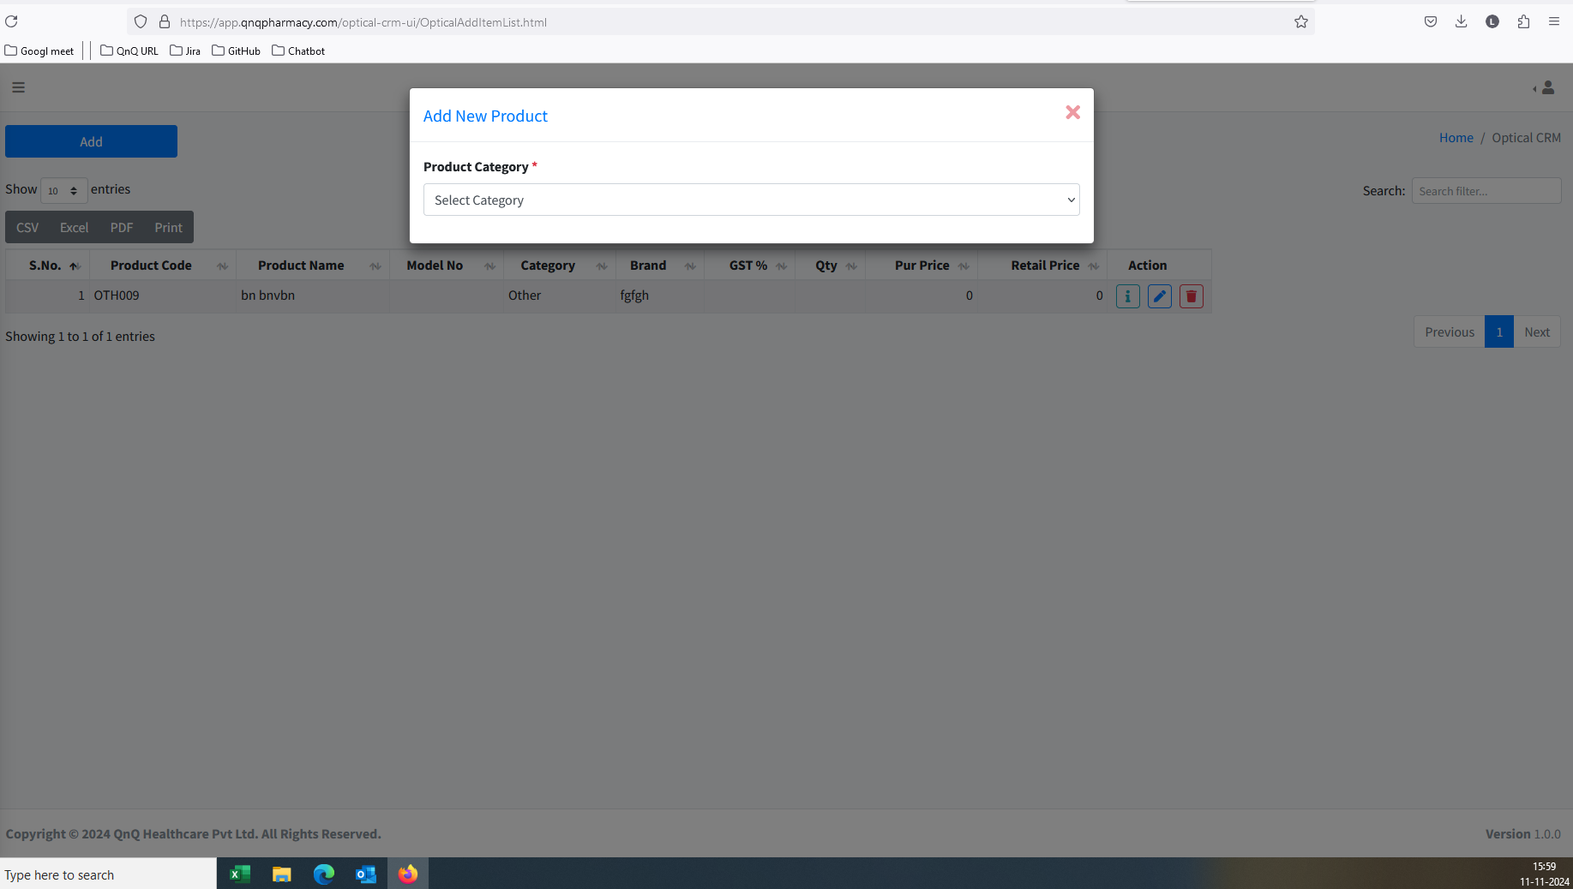 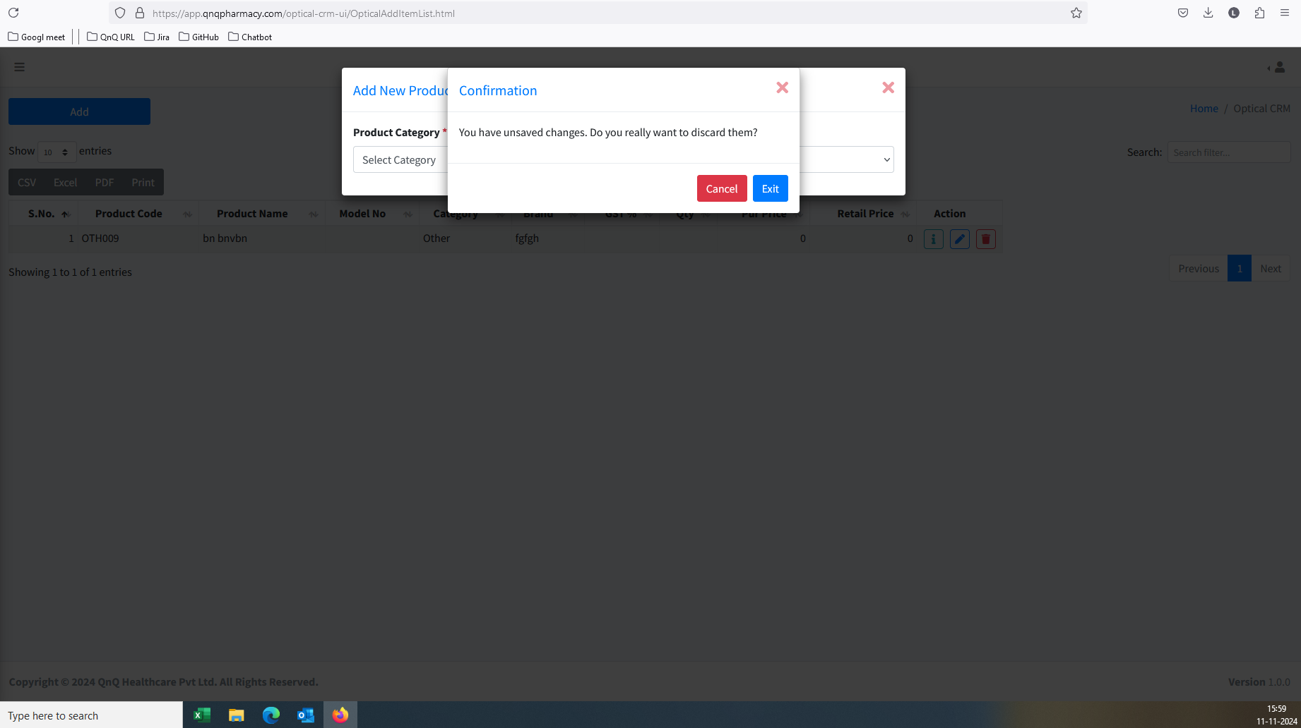 //
11. Placeholder/Inner Text not display in any field 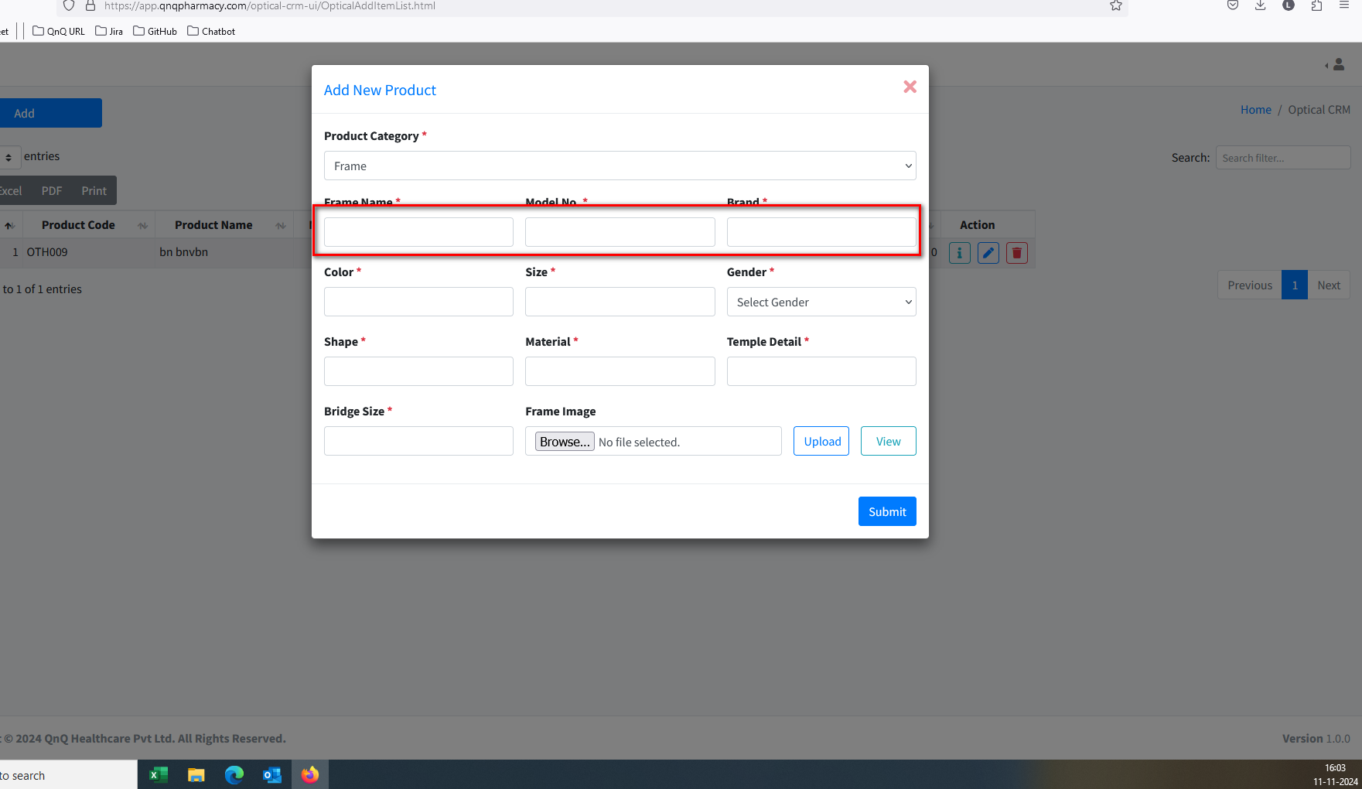 //
12. Unable to create the Frame record 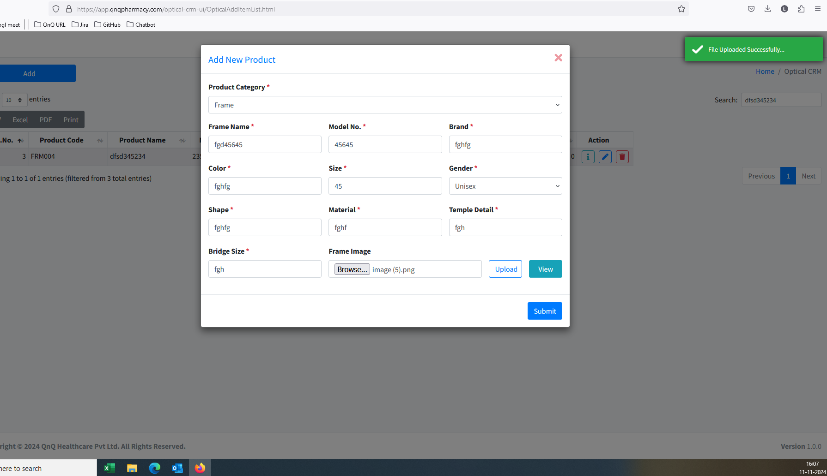 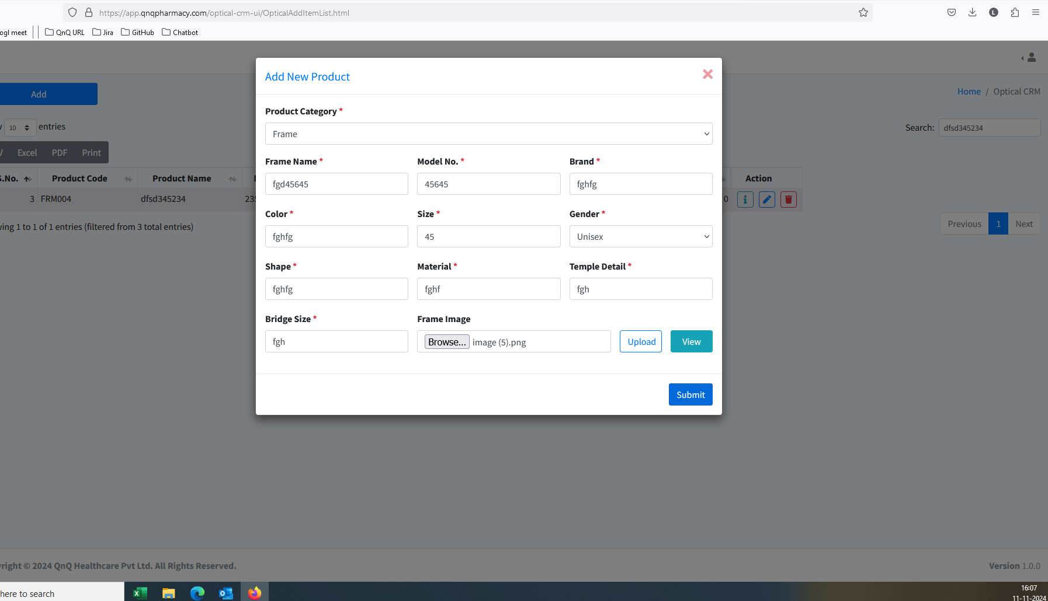 //
13. Uploaded file not display in Edit mode 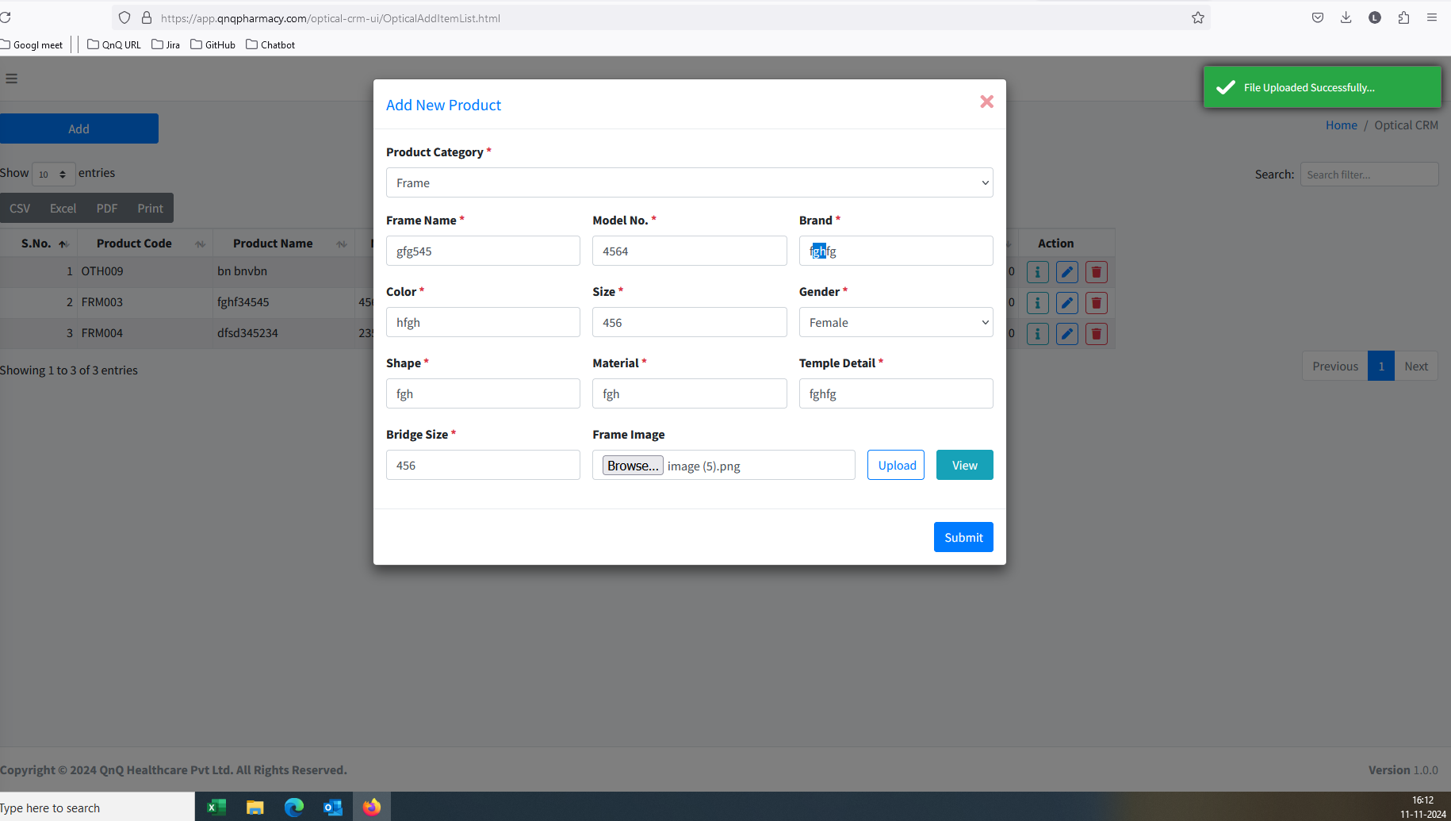 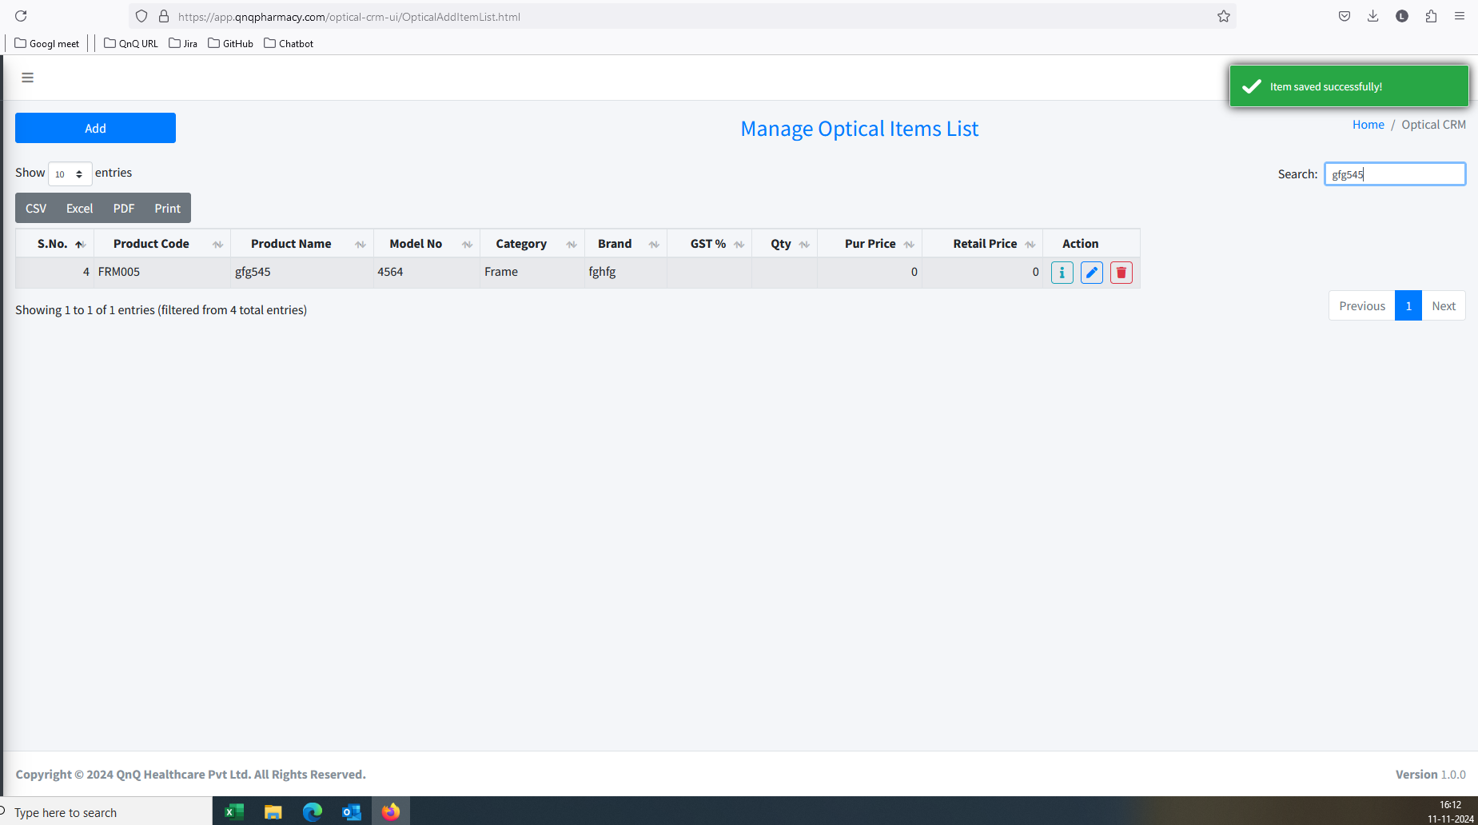 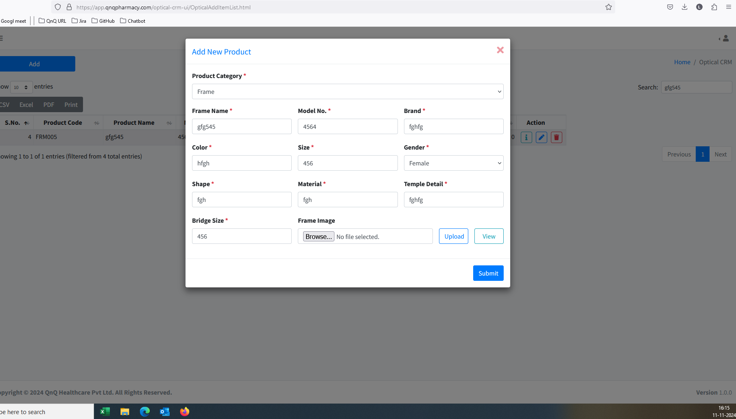 //
14. Success message display mismatch content 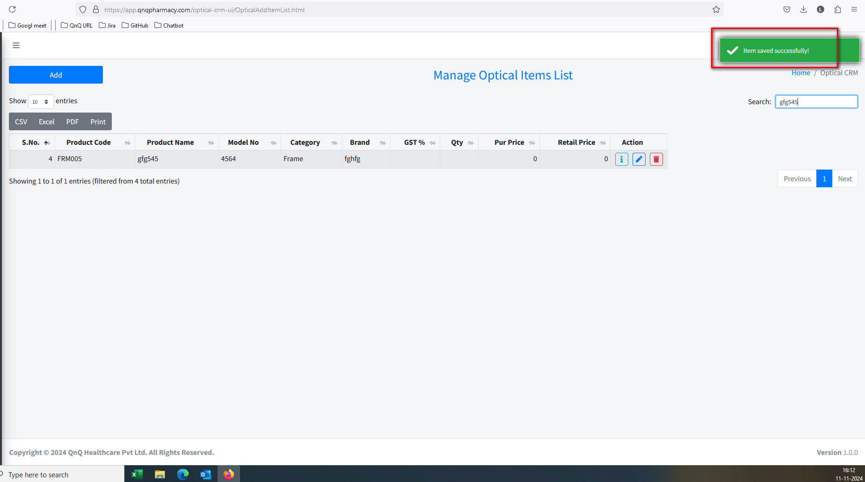 //
15. Update message display mismatch content 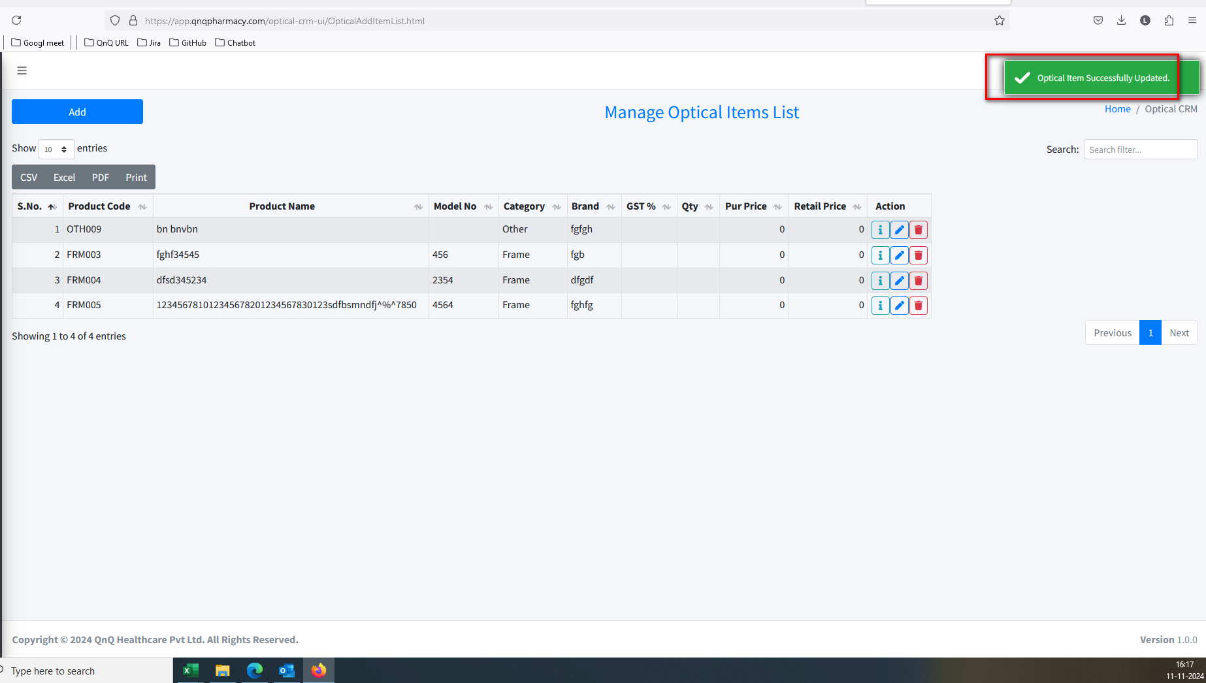 //
16. System not getting display while delete the record 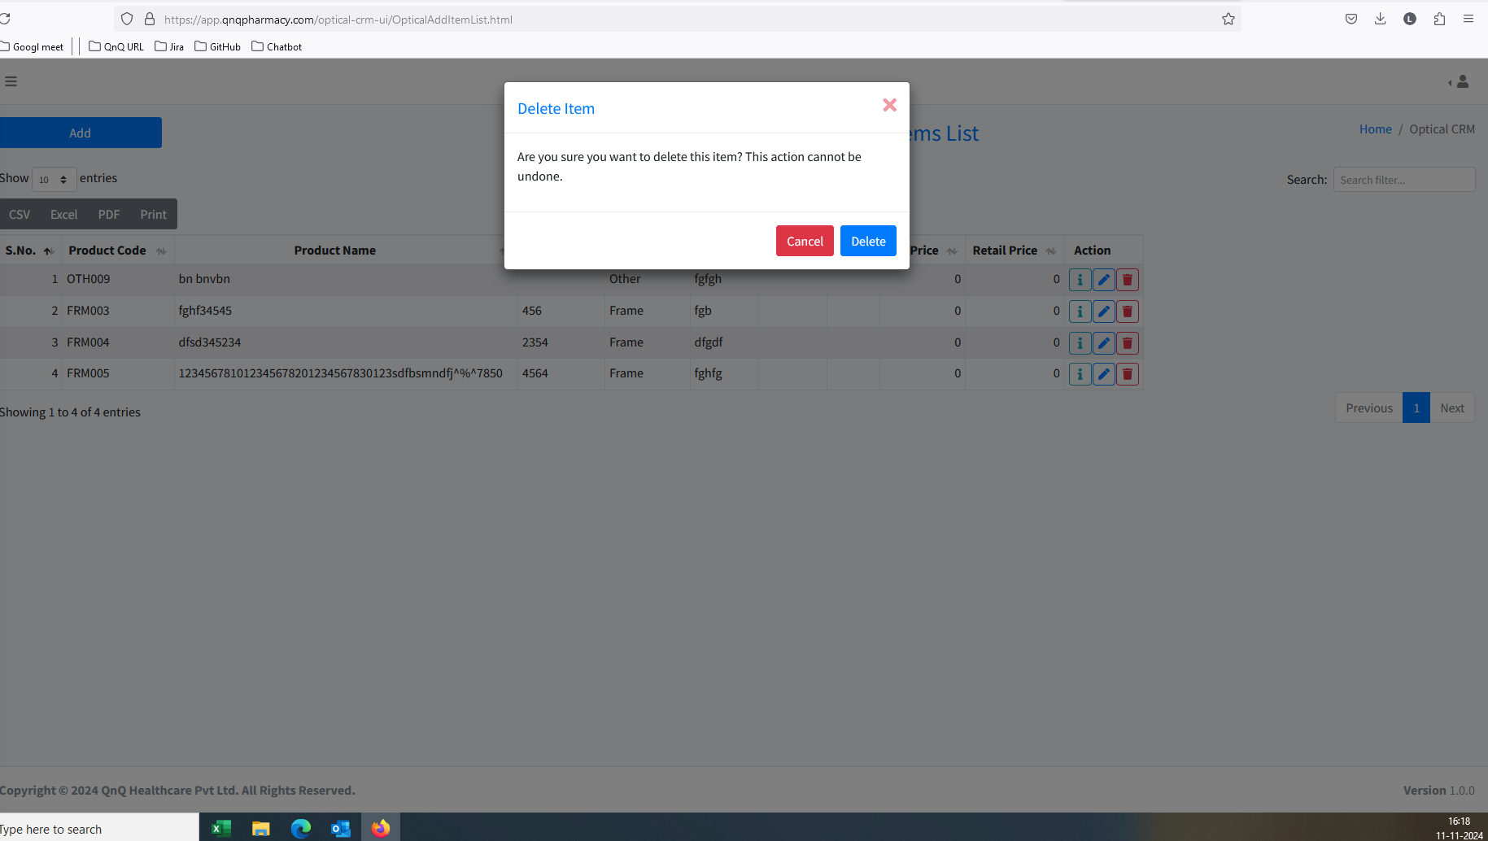 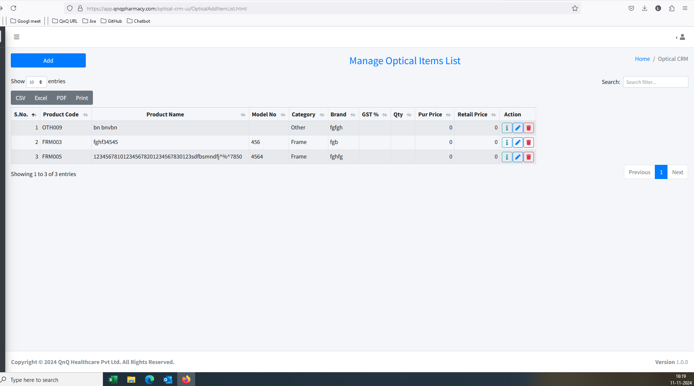 //
17. Unwanted content display while click delete icon 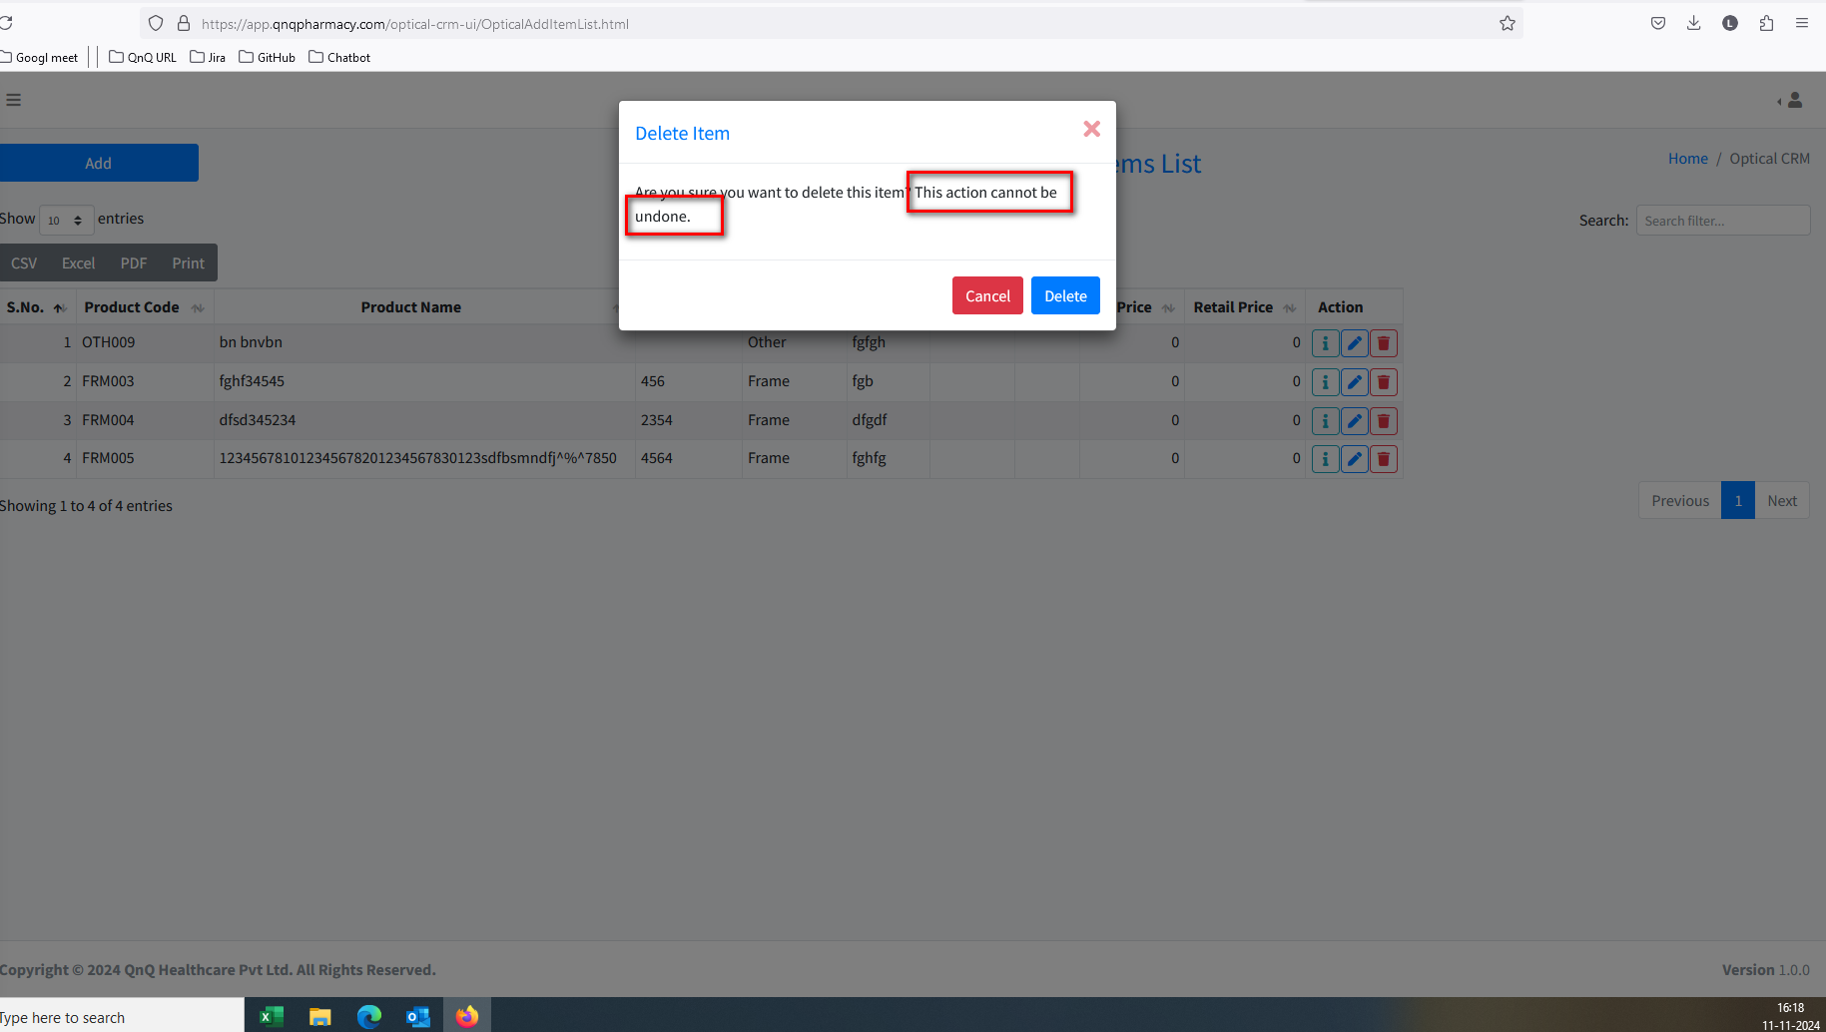 //
18. Updated success message display without updates any value 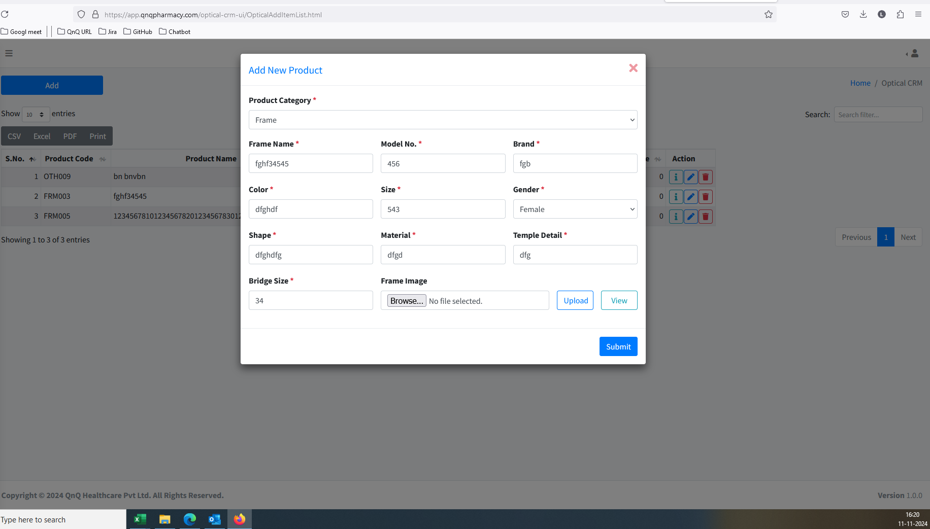 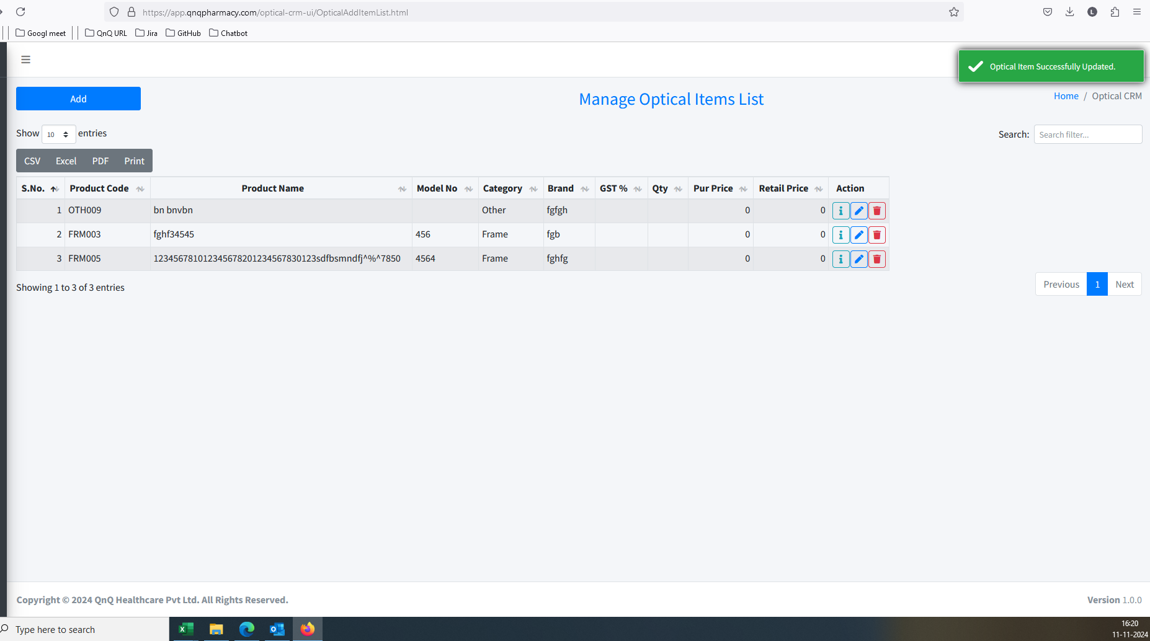 //
19. Unwanted Clear icon display in all fields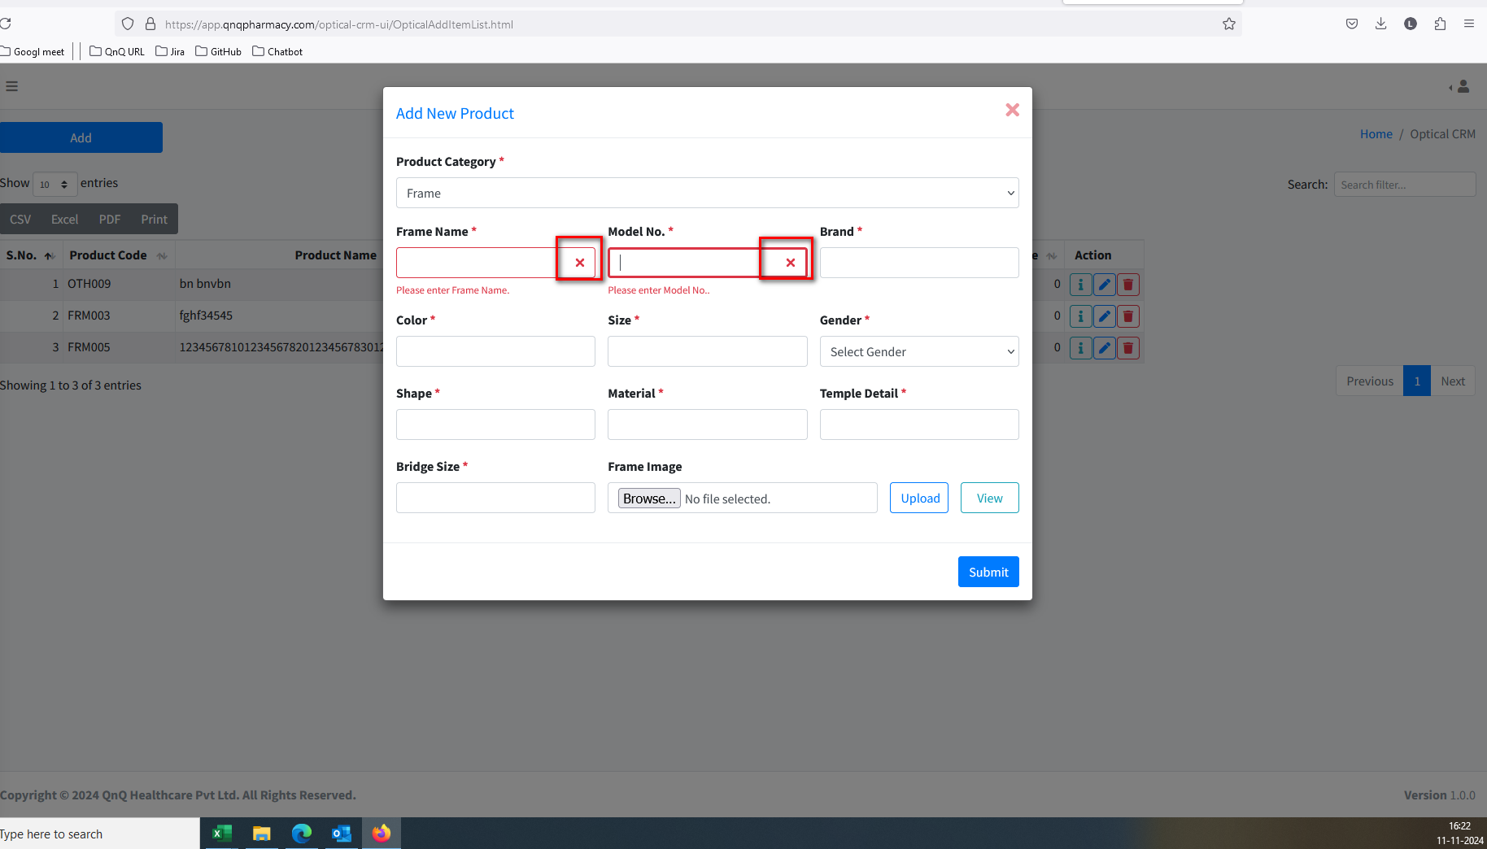 //
20. Mismatch Pop up title display in edit mode 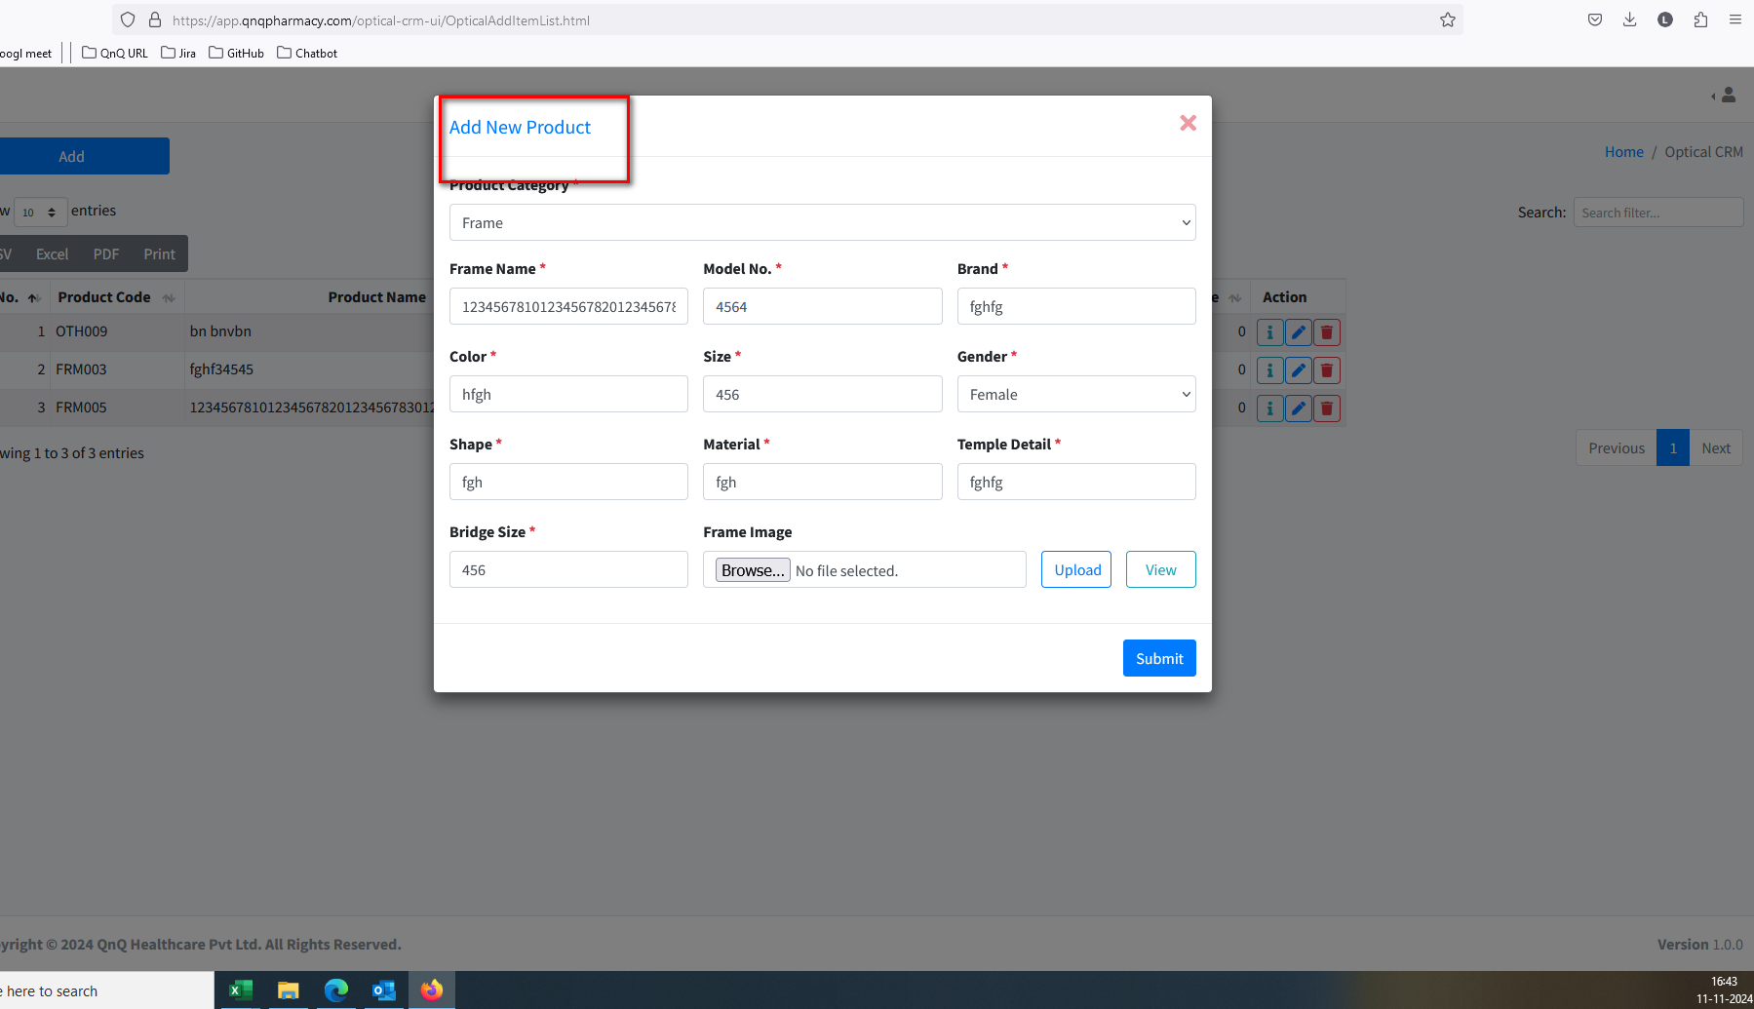 //
21. Tool tip not display for Close icon in More info pop up 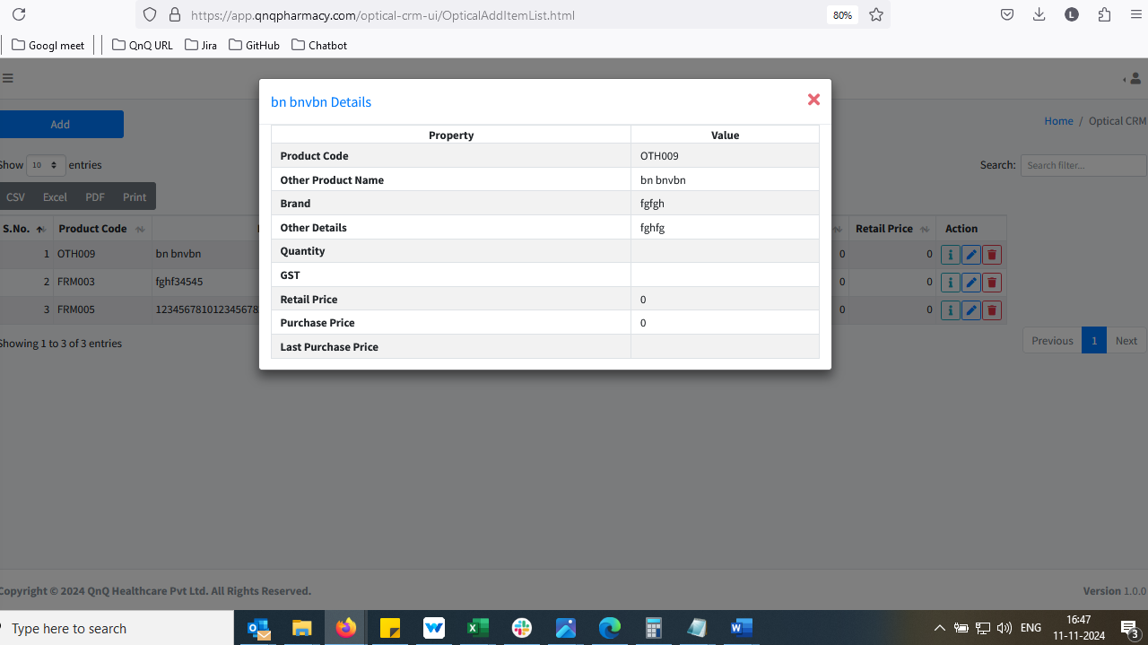 //
22. The size field allow letters and special symbols when enter/pasting content 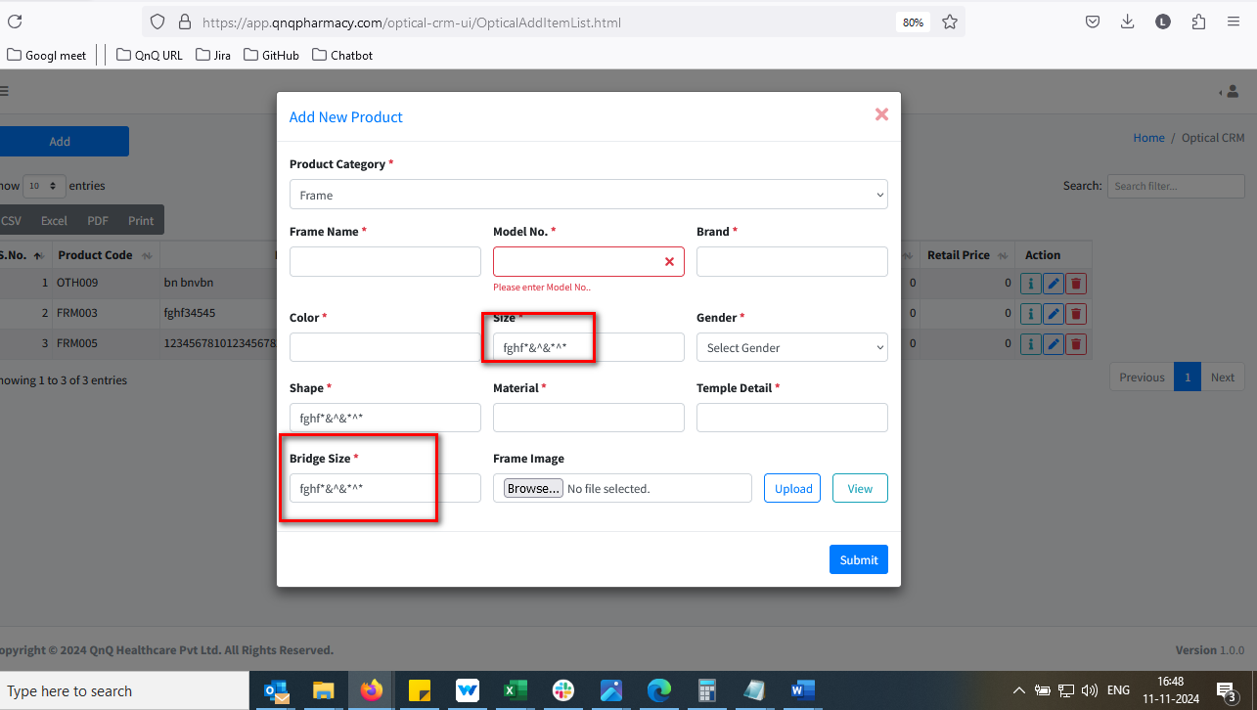 /
23. Unwanted error message while give submit button with max value 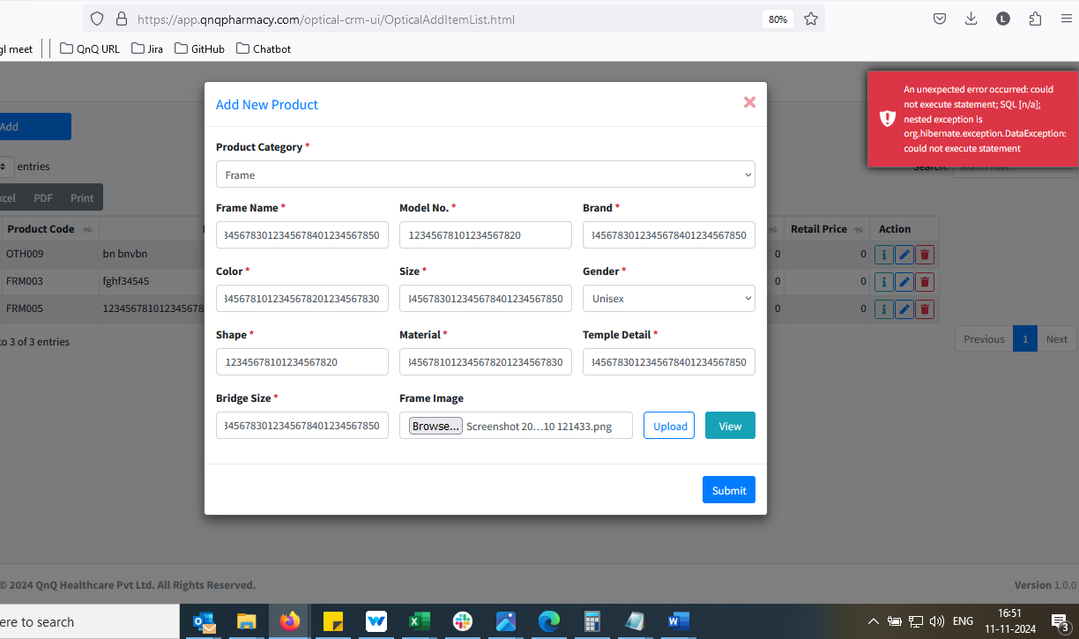 //
24. File not attached message not display while click the upload button without upload any button 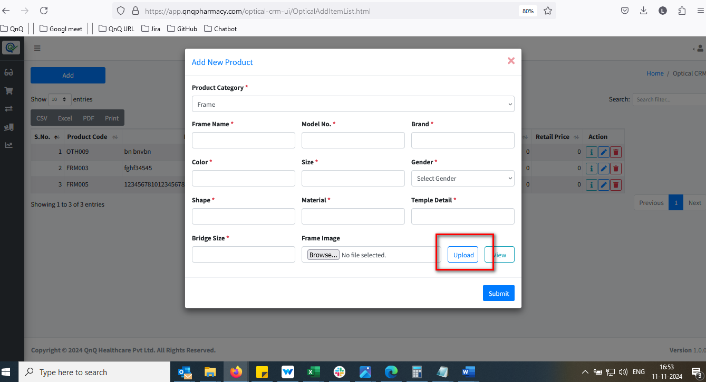 //
25. System not getting allow 5 mb file  //
26. File upload error message not display while click submit button without click upload button 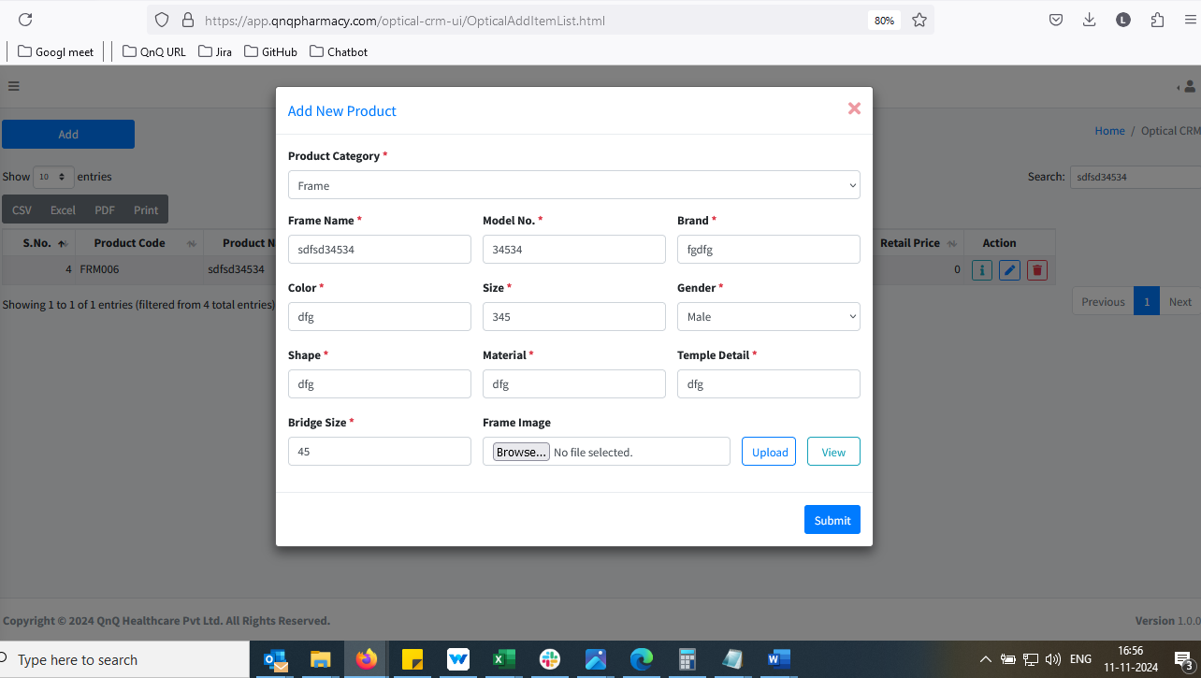 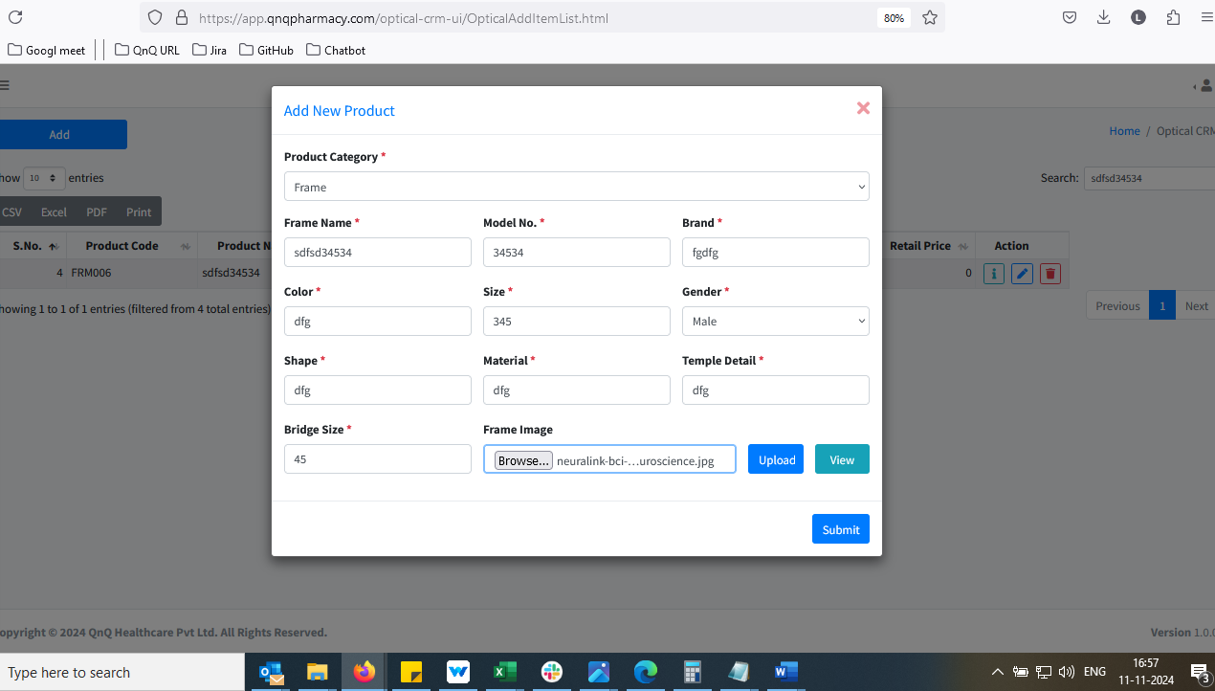 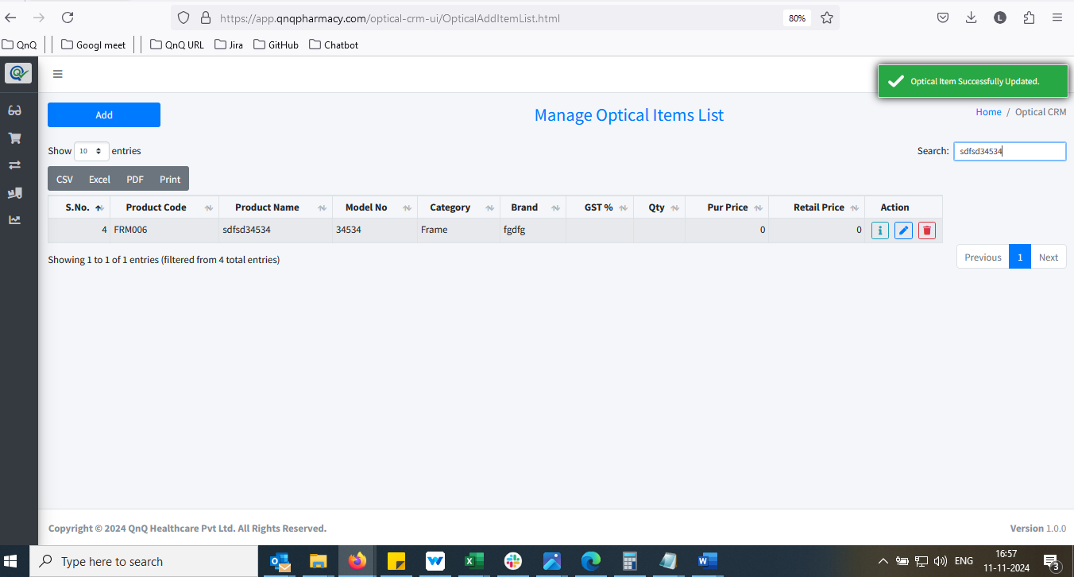 //
27. Mismatch column header name not display in list grid 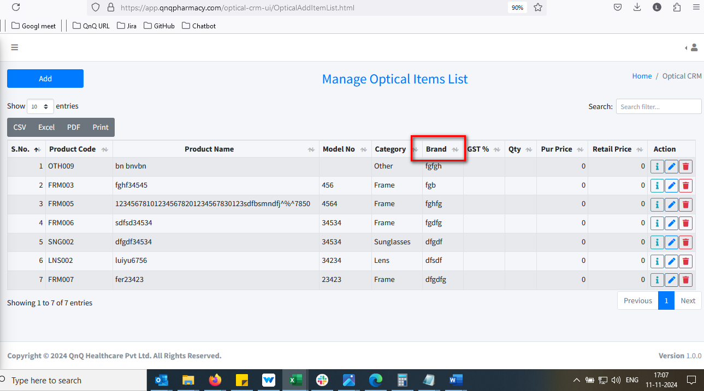 //
28. Unwanted file path display in upload section 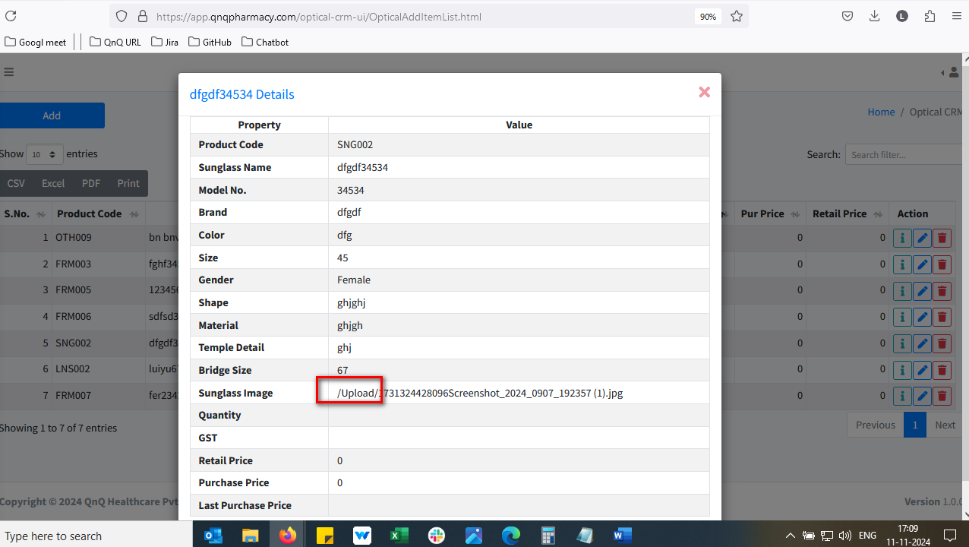 //
29. Mismatch Title header display in More Info pop up 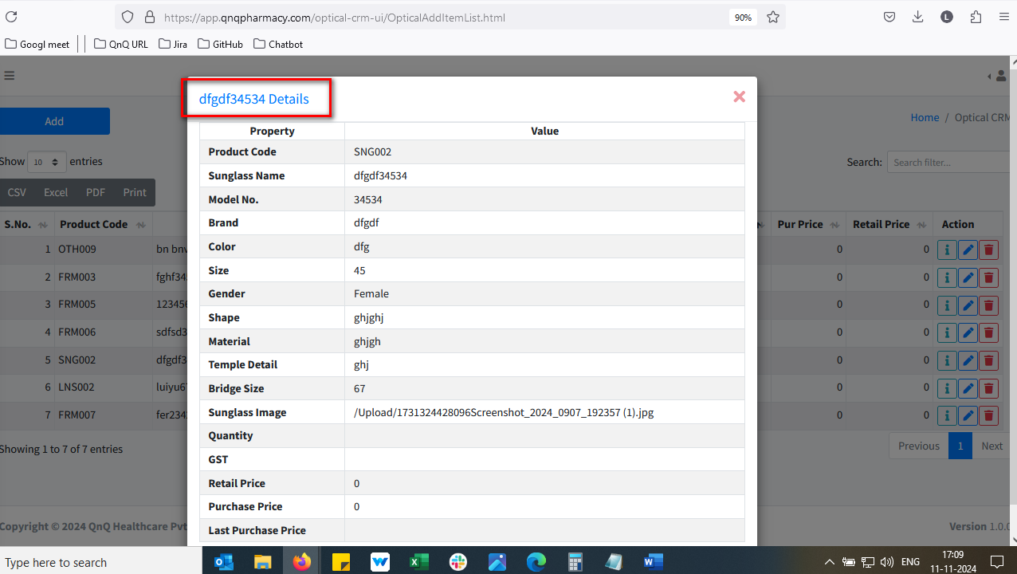 //
30. Mismatch header column display in More Info pop up 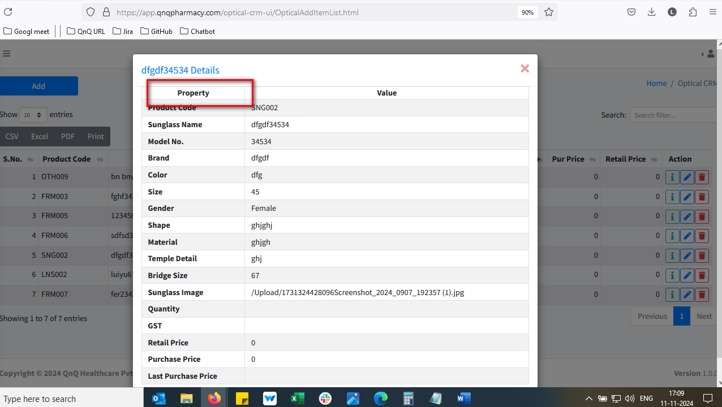 //
31. Unwanted column display in More Infor pop up 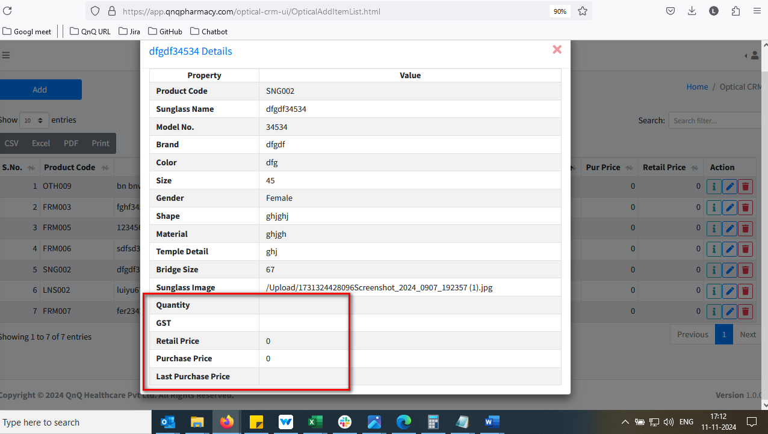 //
32. Improper alignment display in more Info pop up  //
33. User can able to update the Product Category field in edit mode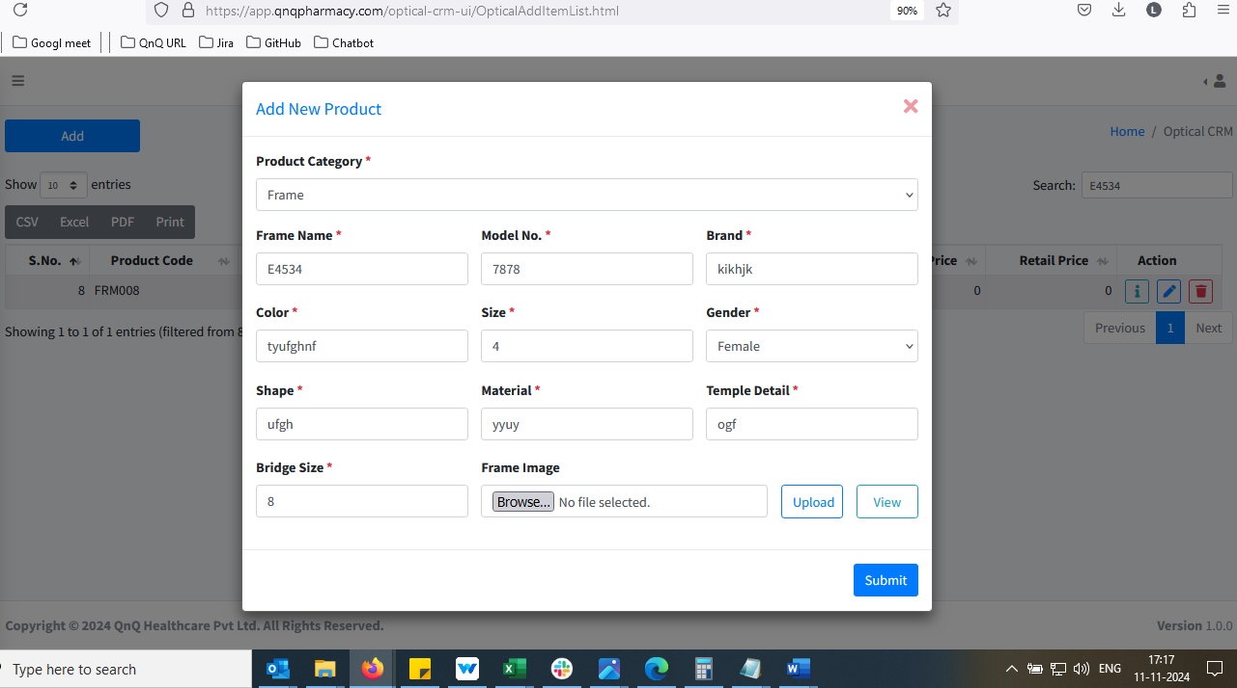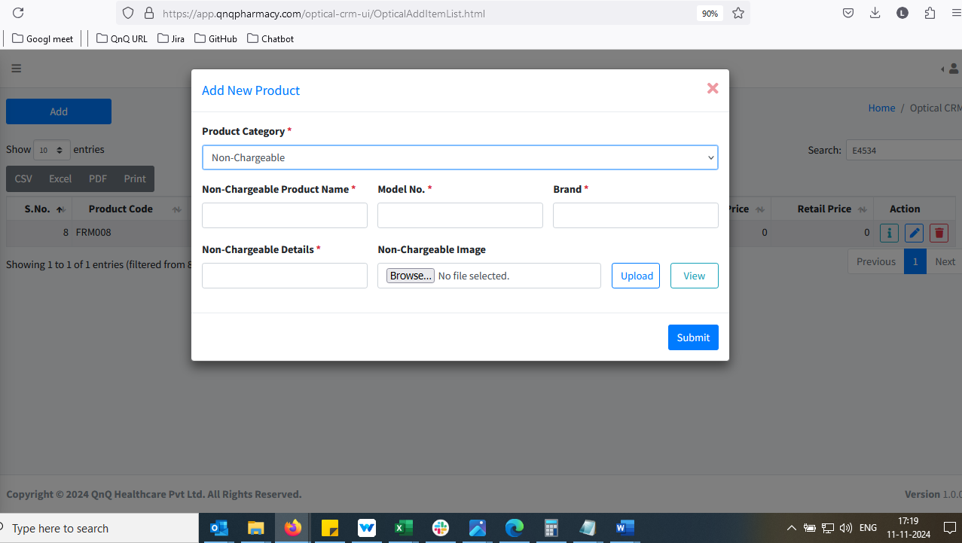//
34. Display error messages with lowercase initial letters 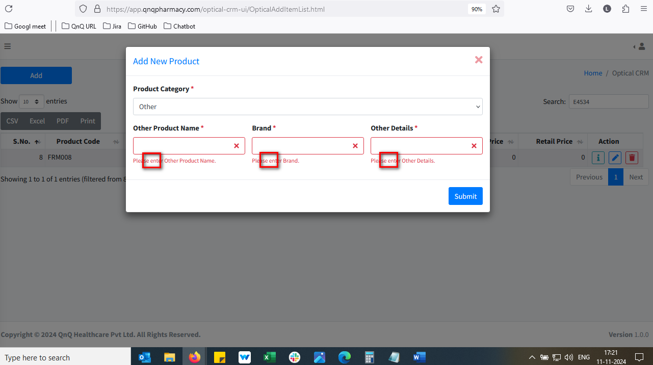 //
35. Given Contact Lens Base Curves value not display in edit mode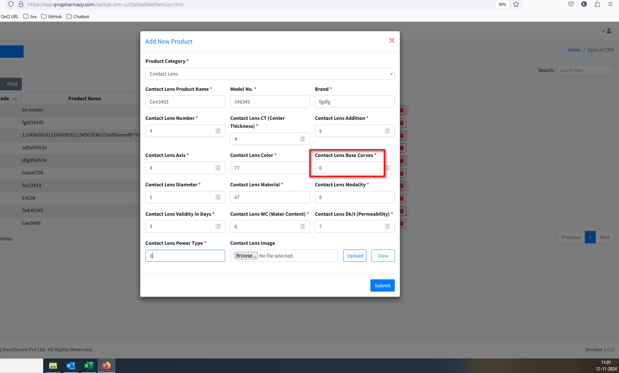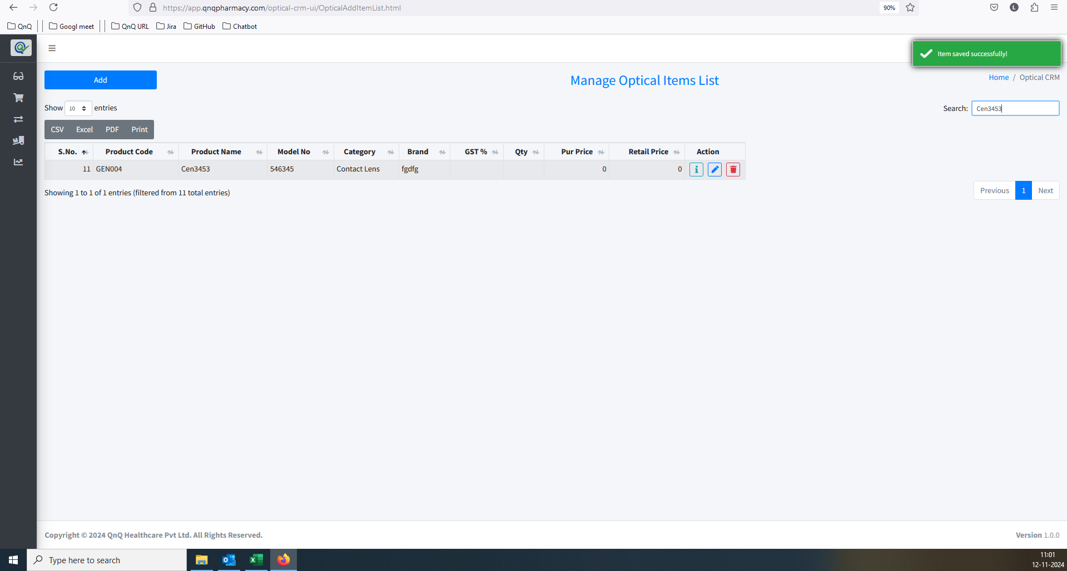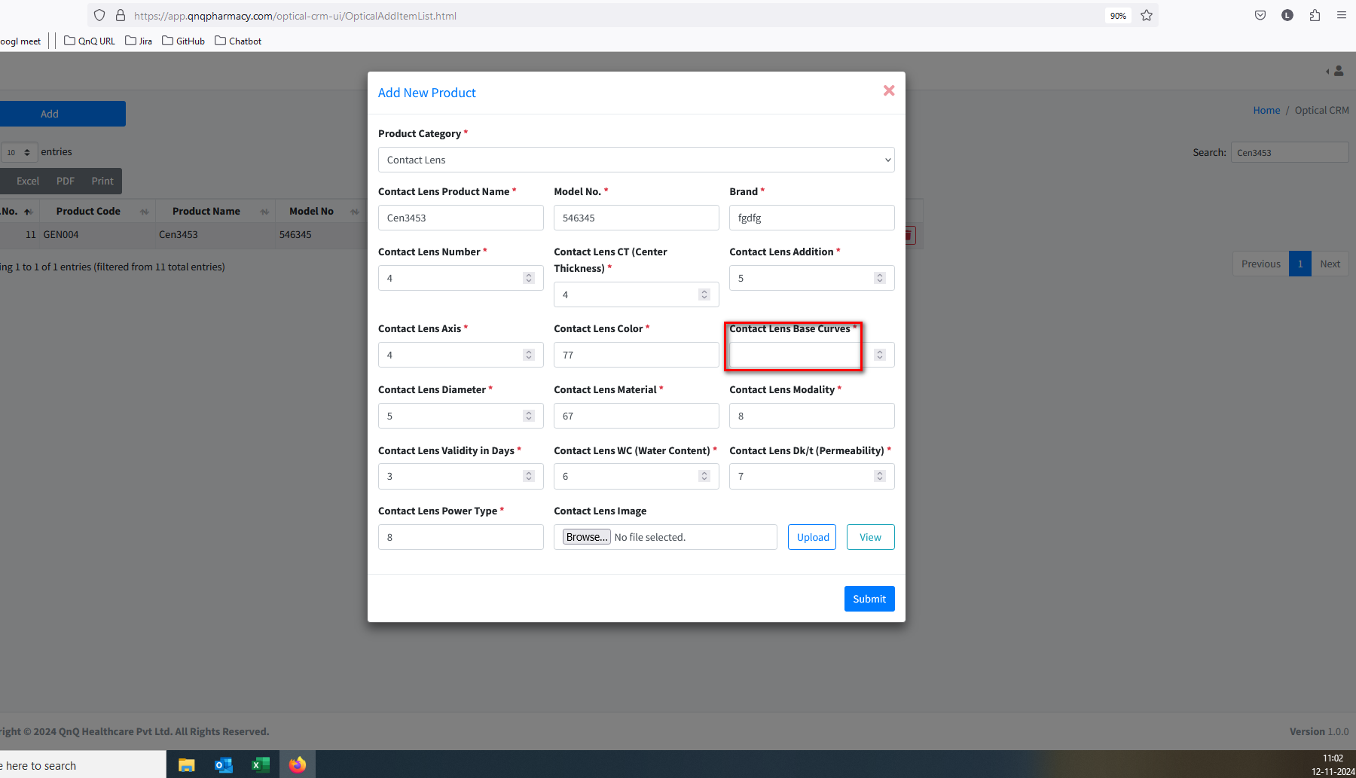//
36. Minus value display in all numbers field while click down arrow button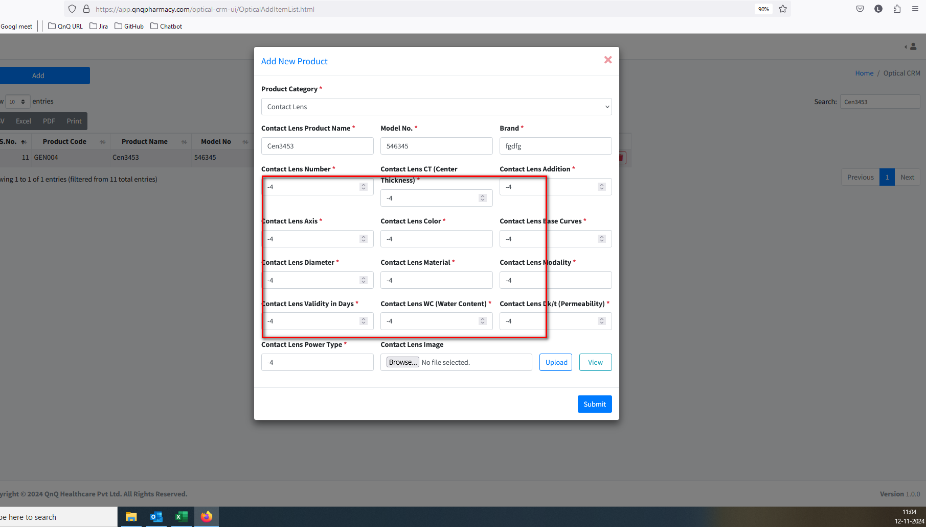//
37. Mismatch Solution Packing Type value display in edit mode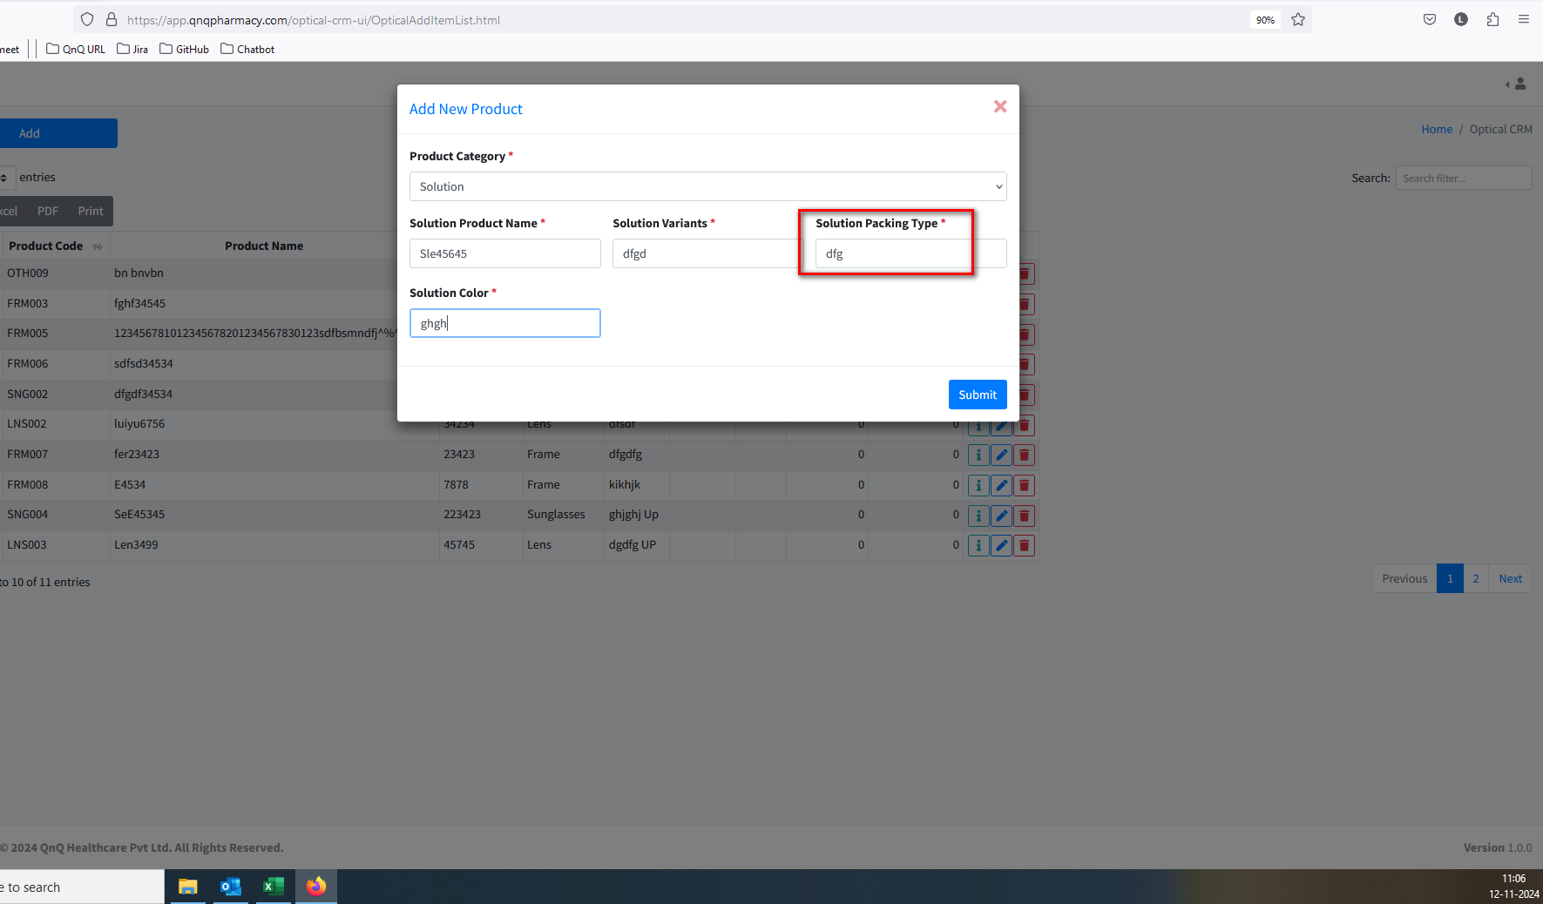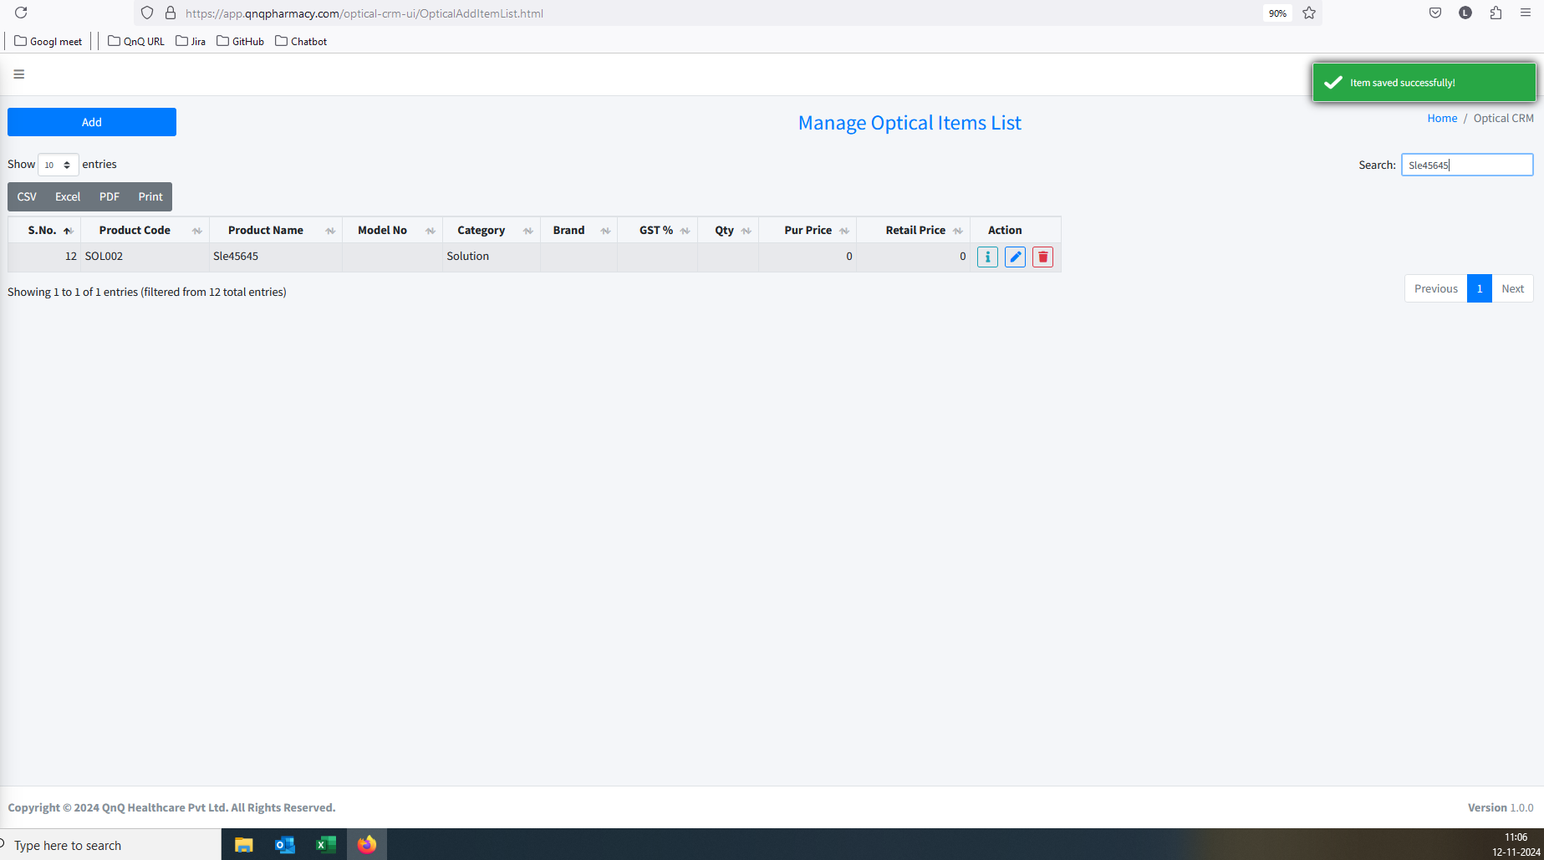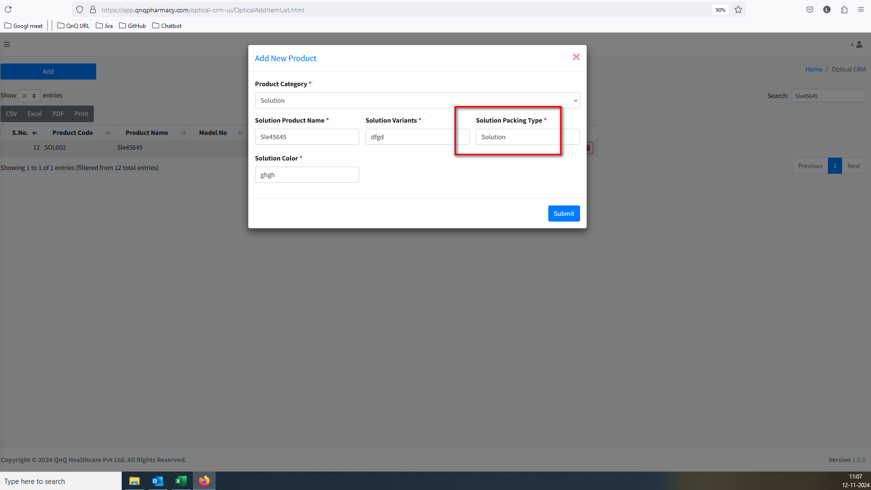//
38. First letter display as small letter in Showing records content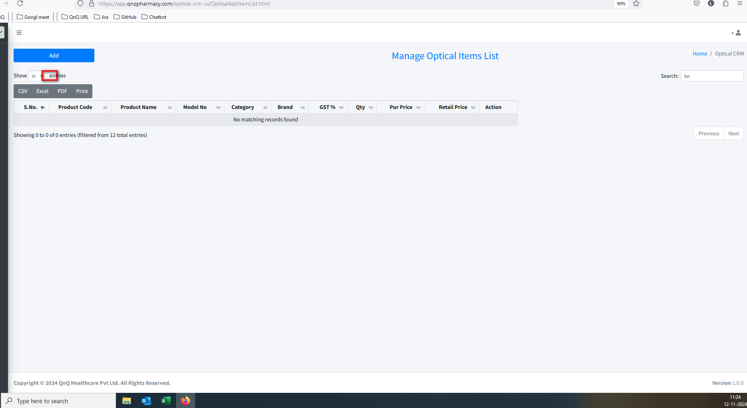//
39. Unwanted confirmation message display while click the Edit button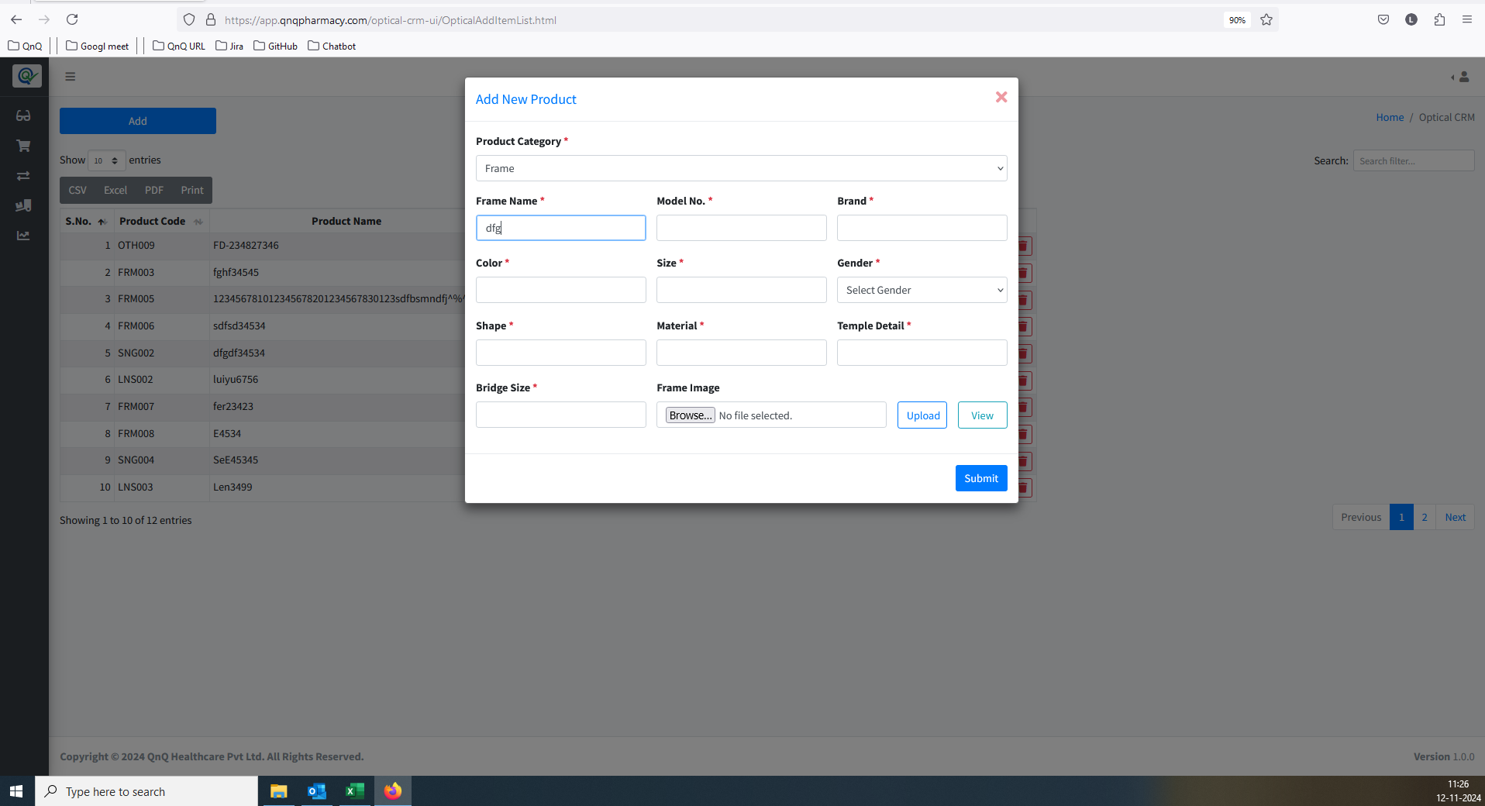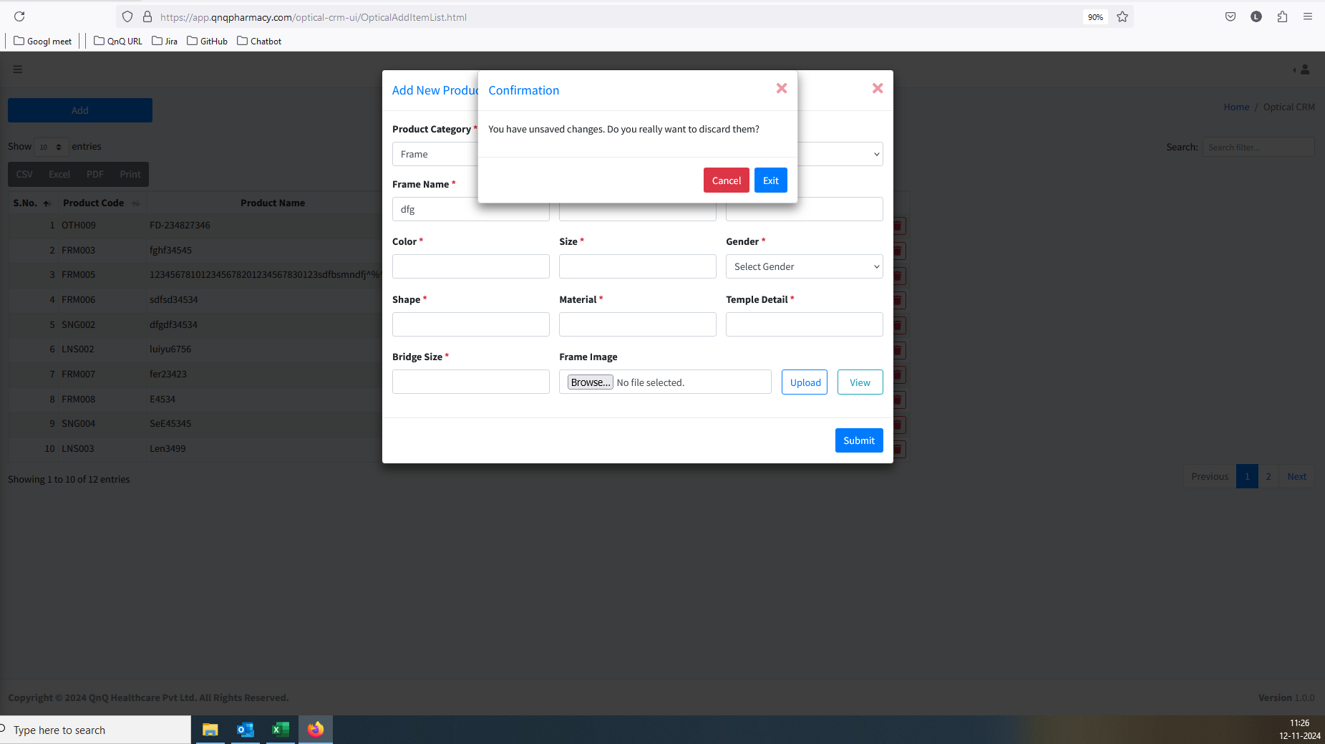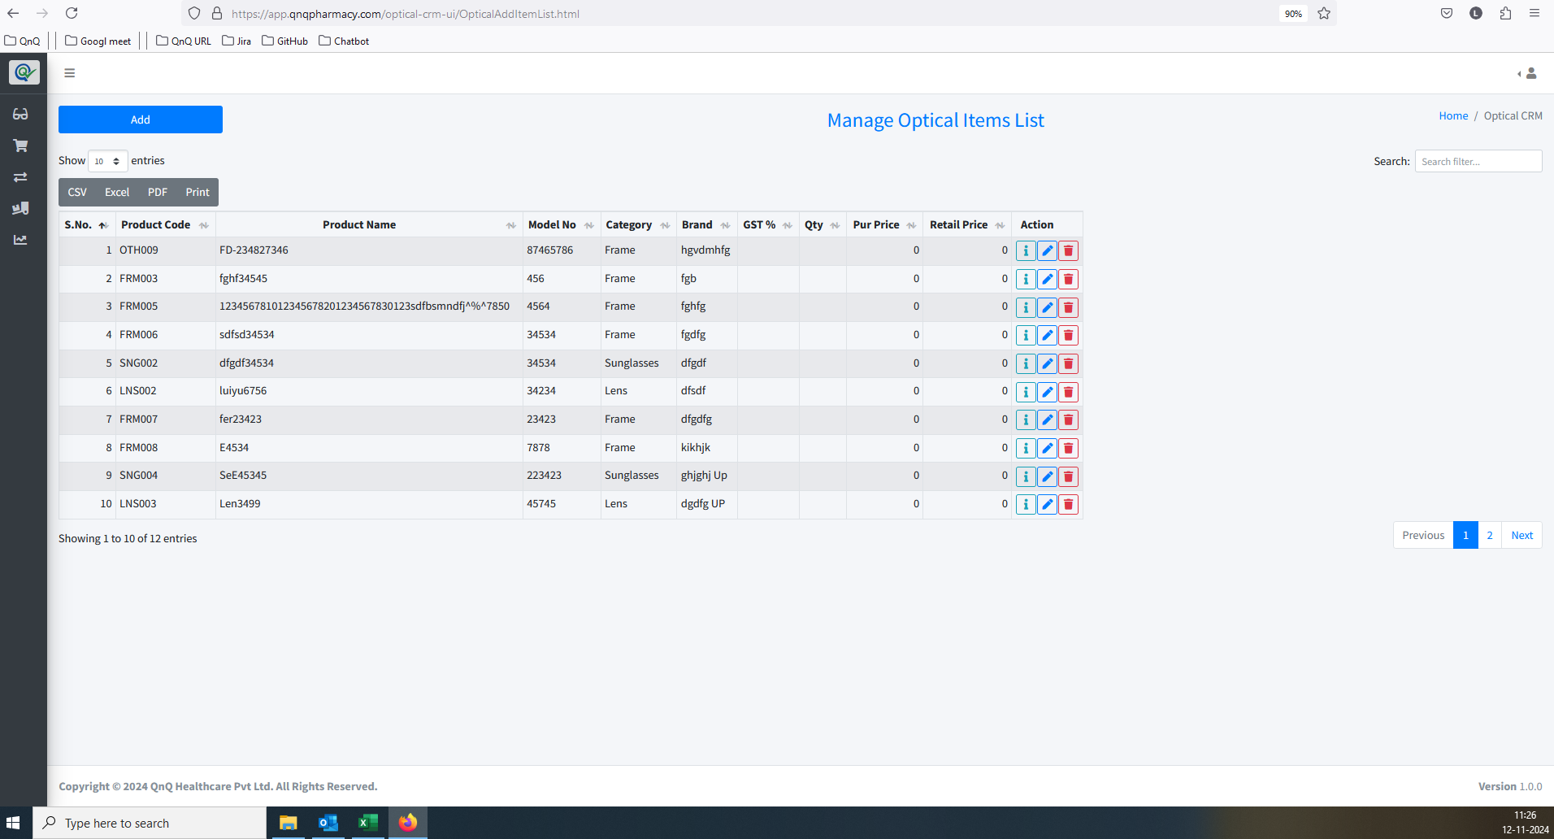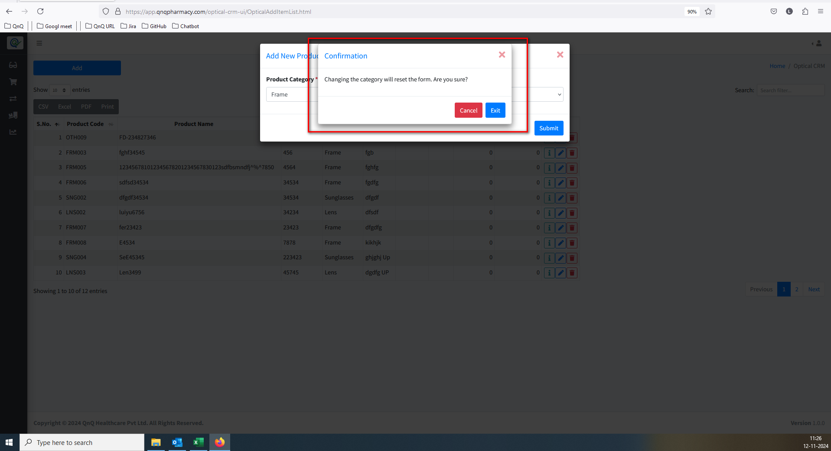//
40. Improper alignment display in Add new button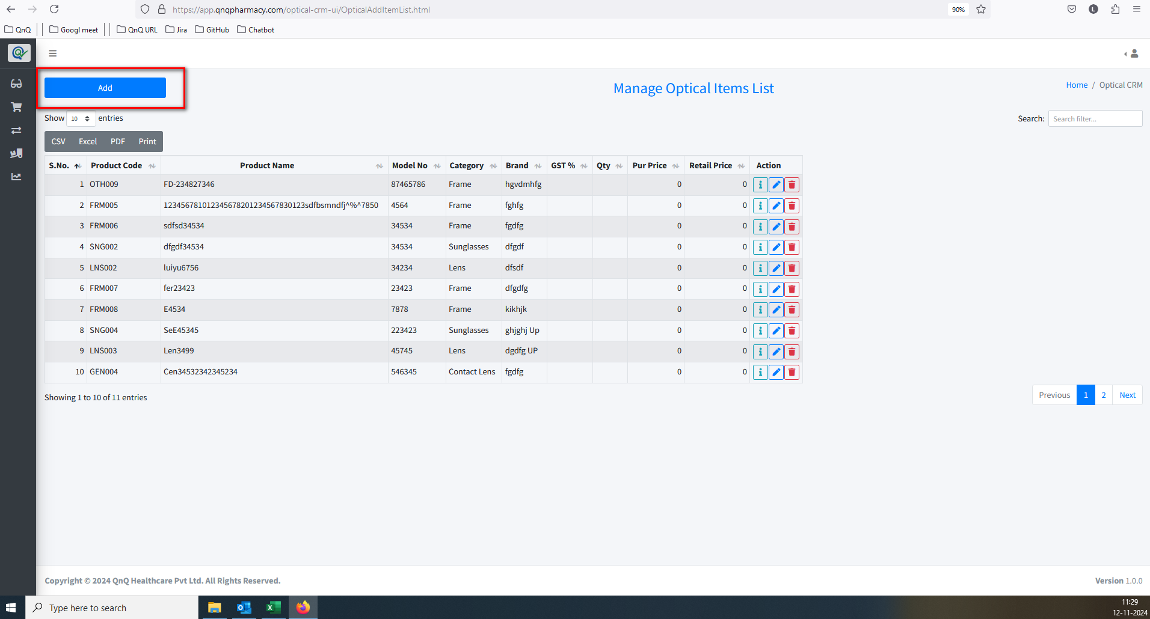//
41. Page not display within the outer line/Card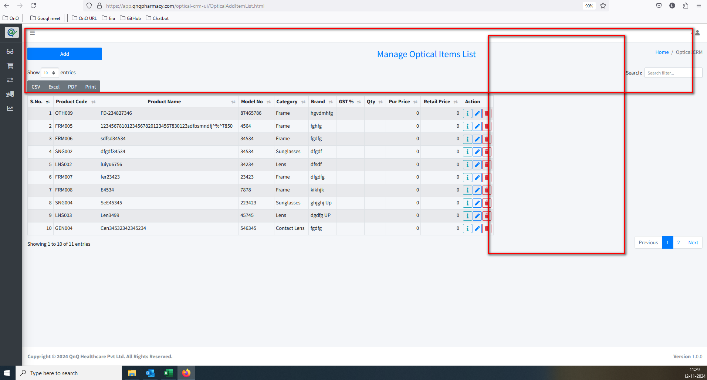//
42. Unwanted content display in Edit/Delete/More Info icon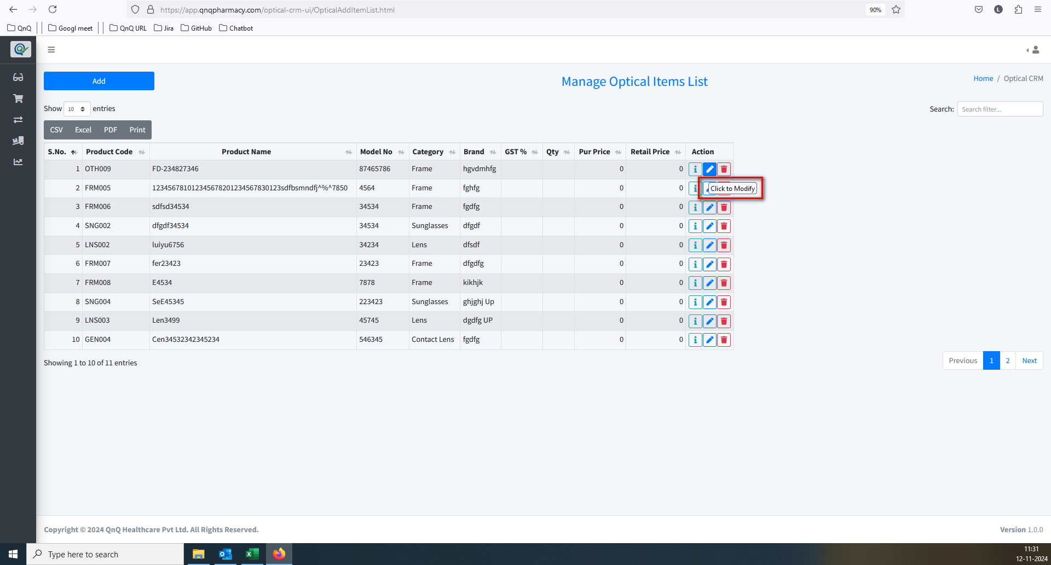//
43. The error message is not displaying the correct content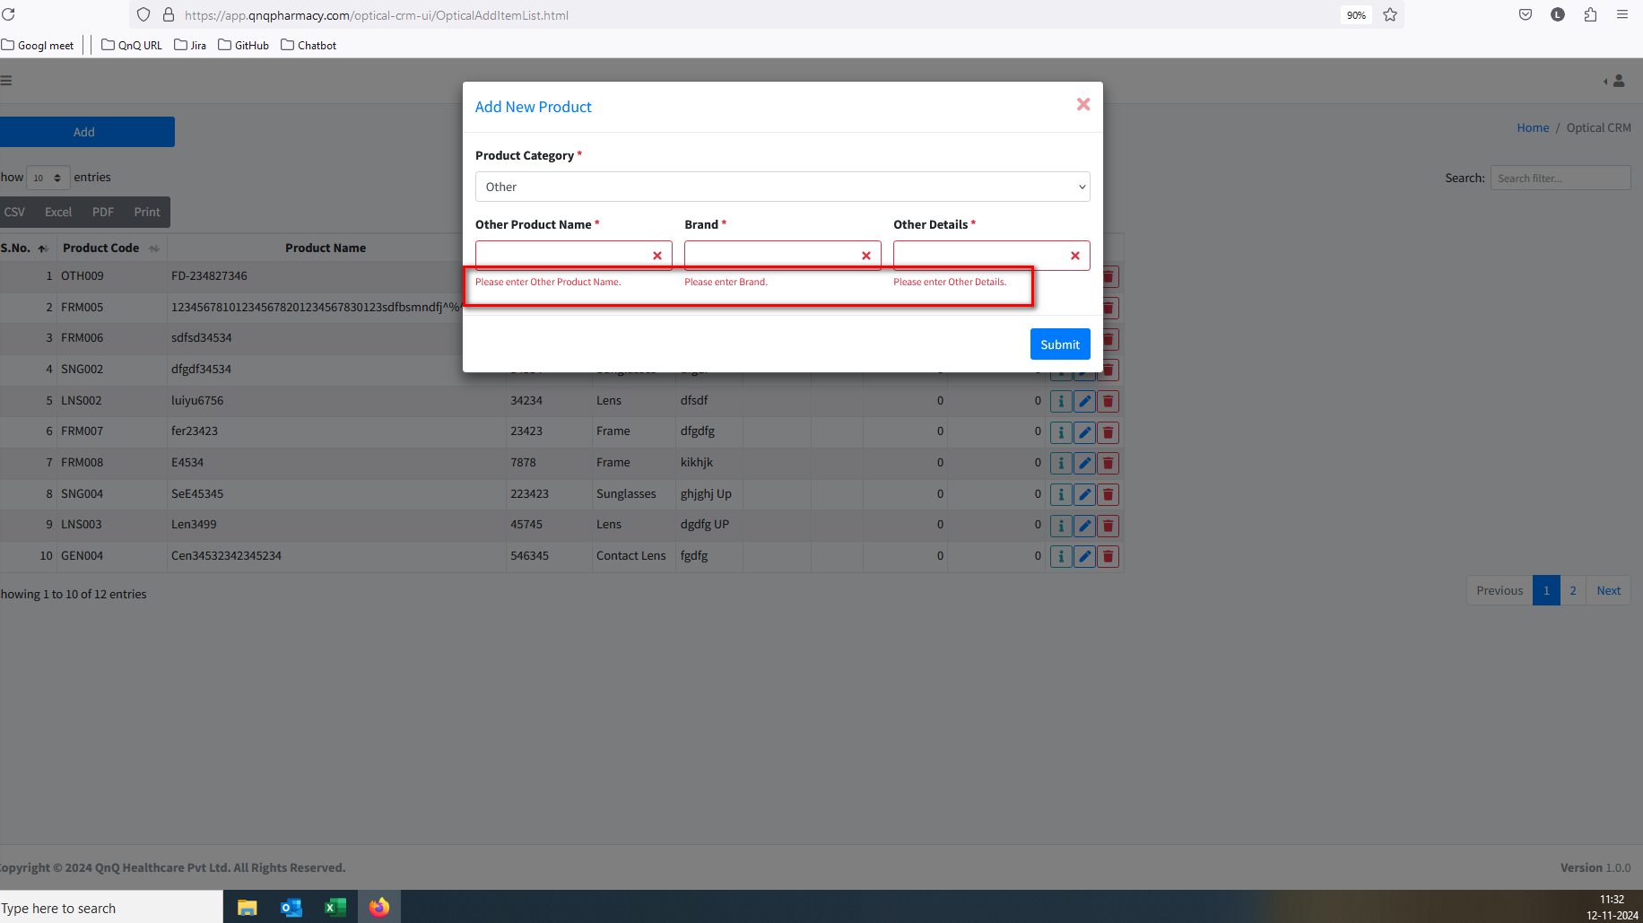//
44. Unwanted bottom line display in pop up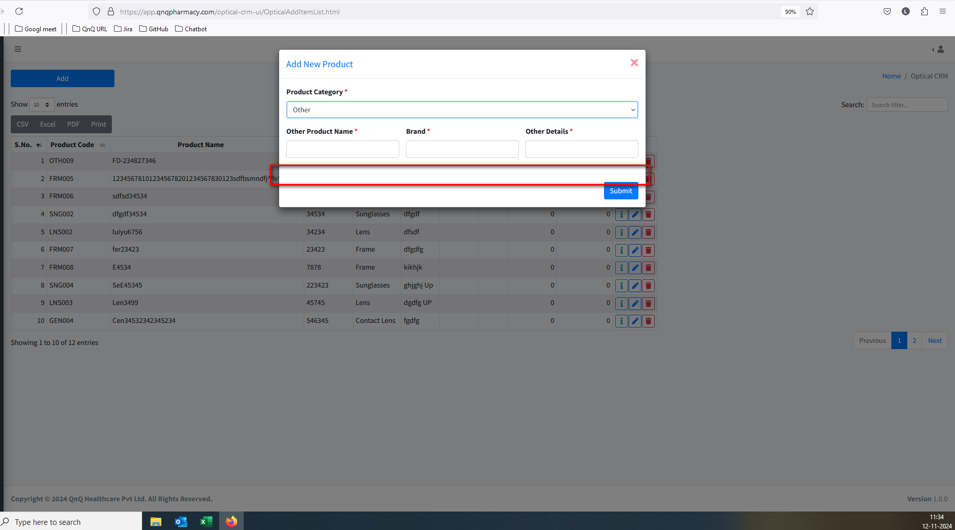//
45. Unable to click upload button attach any file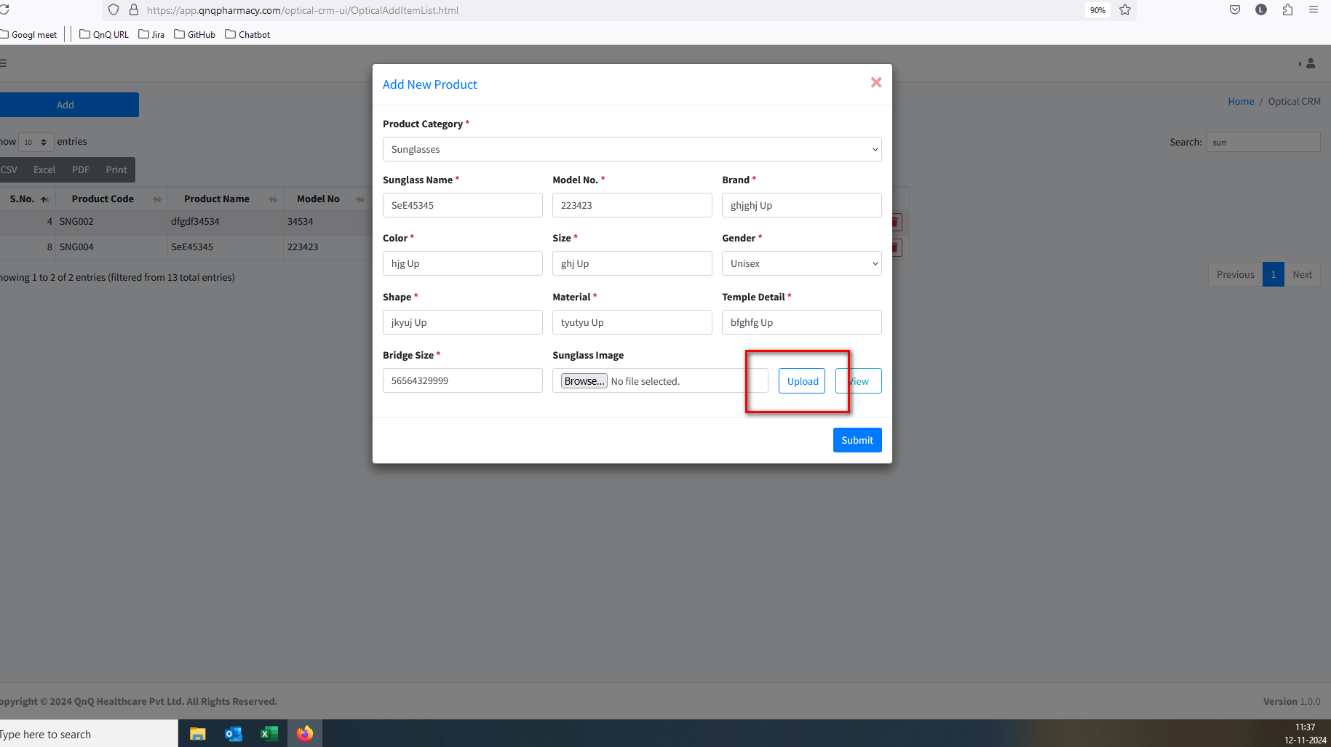//
46. Confirmation message not display while close the pop up with uploaded document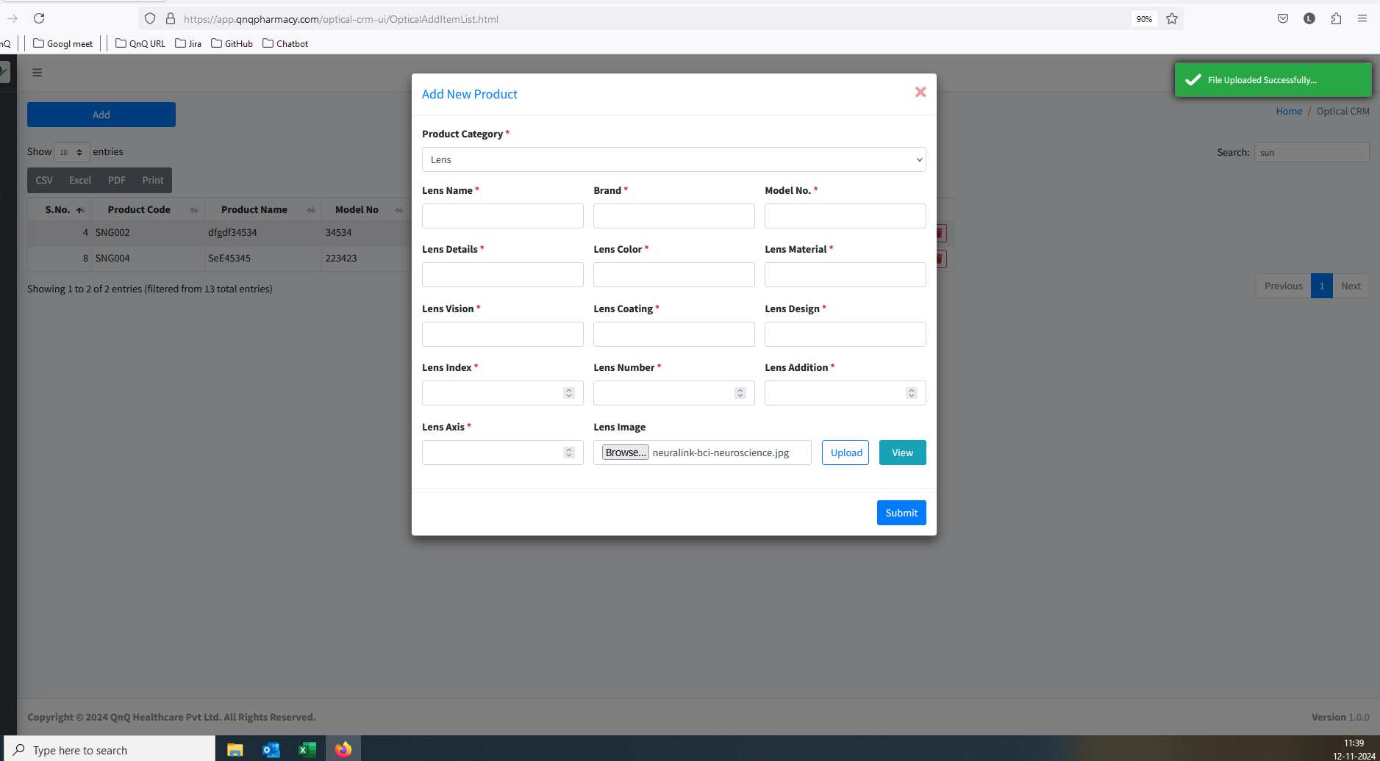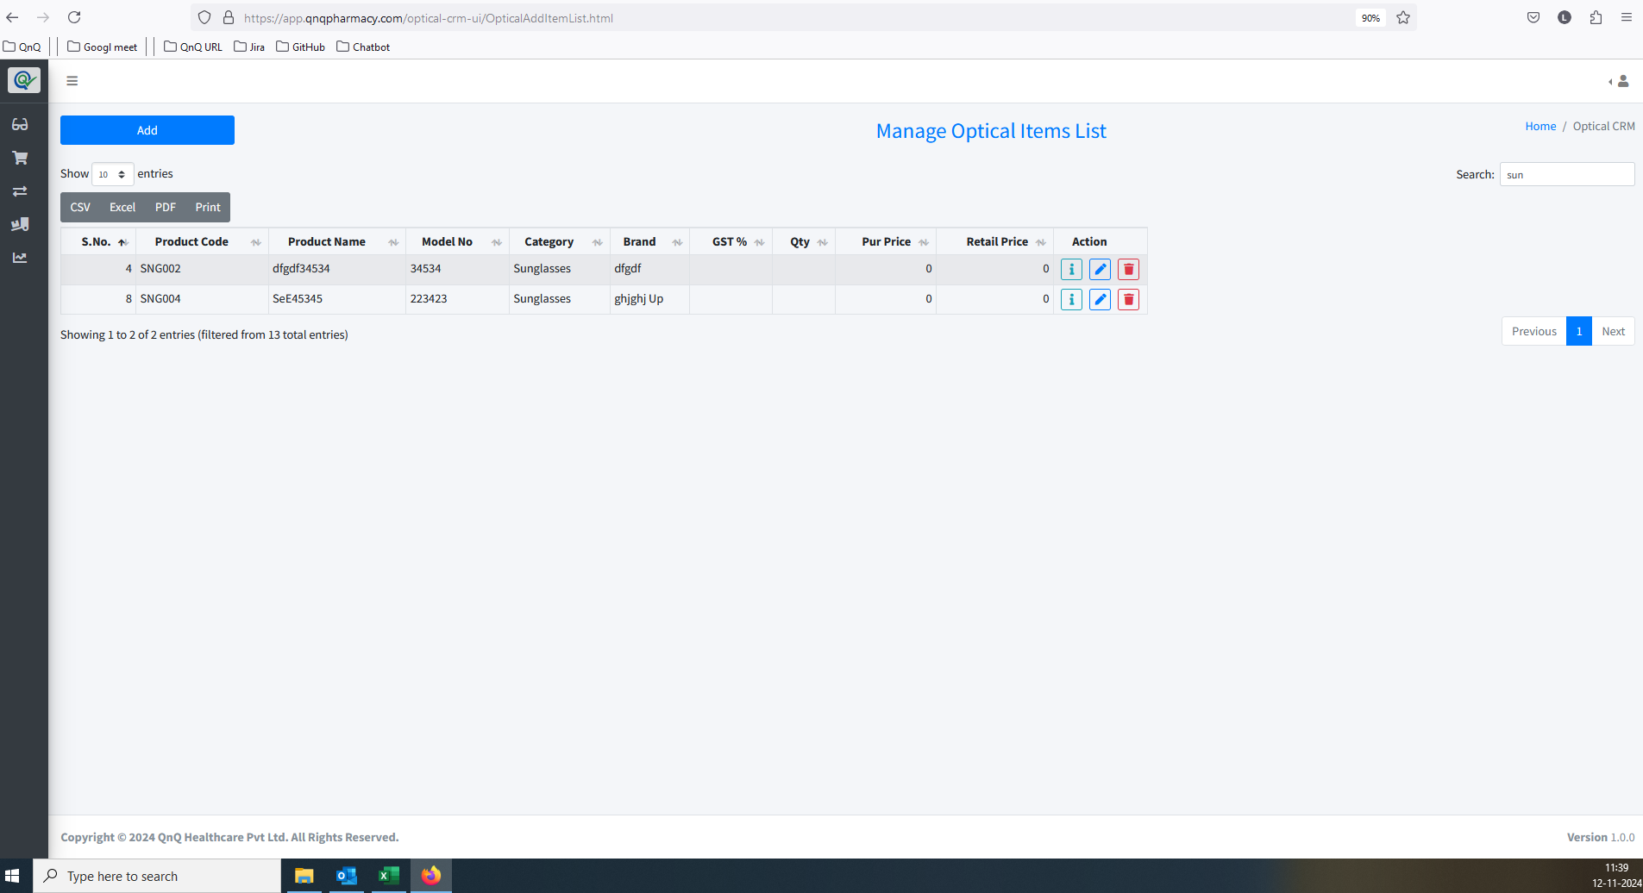//
47. Recently updated record not display as first record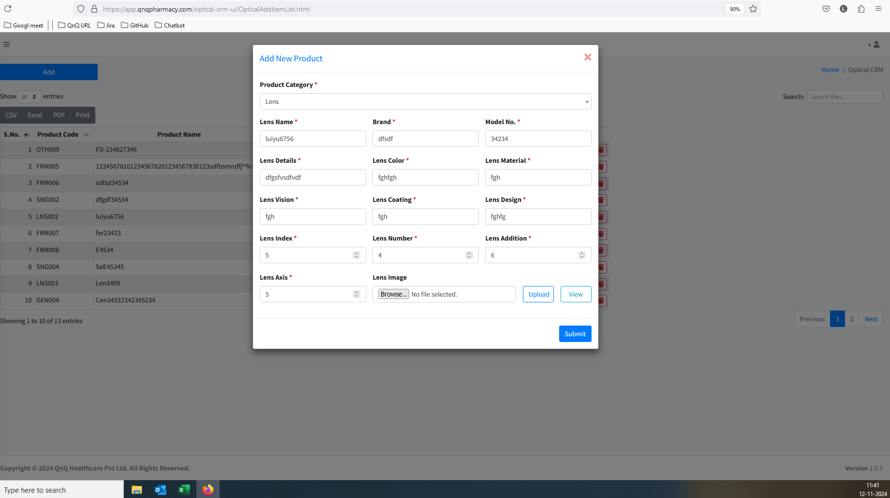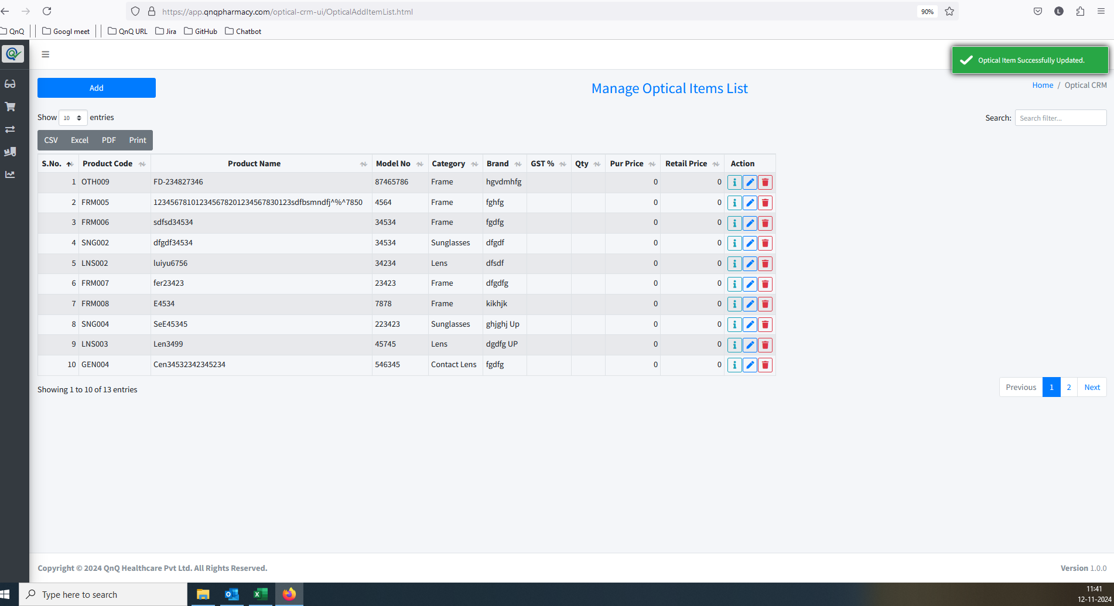//
48. Button name not display as Update in edit mode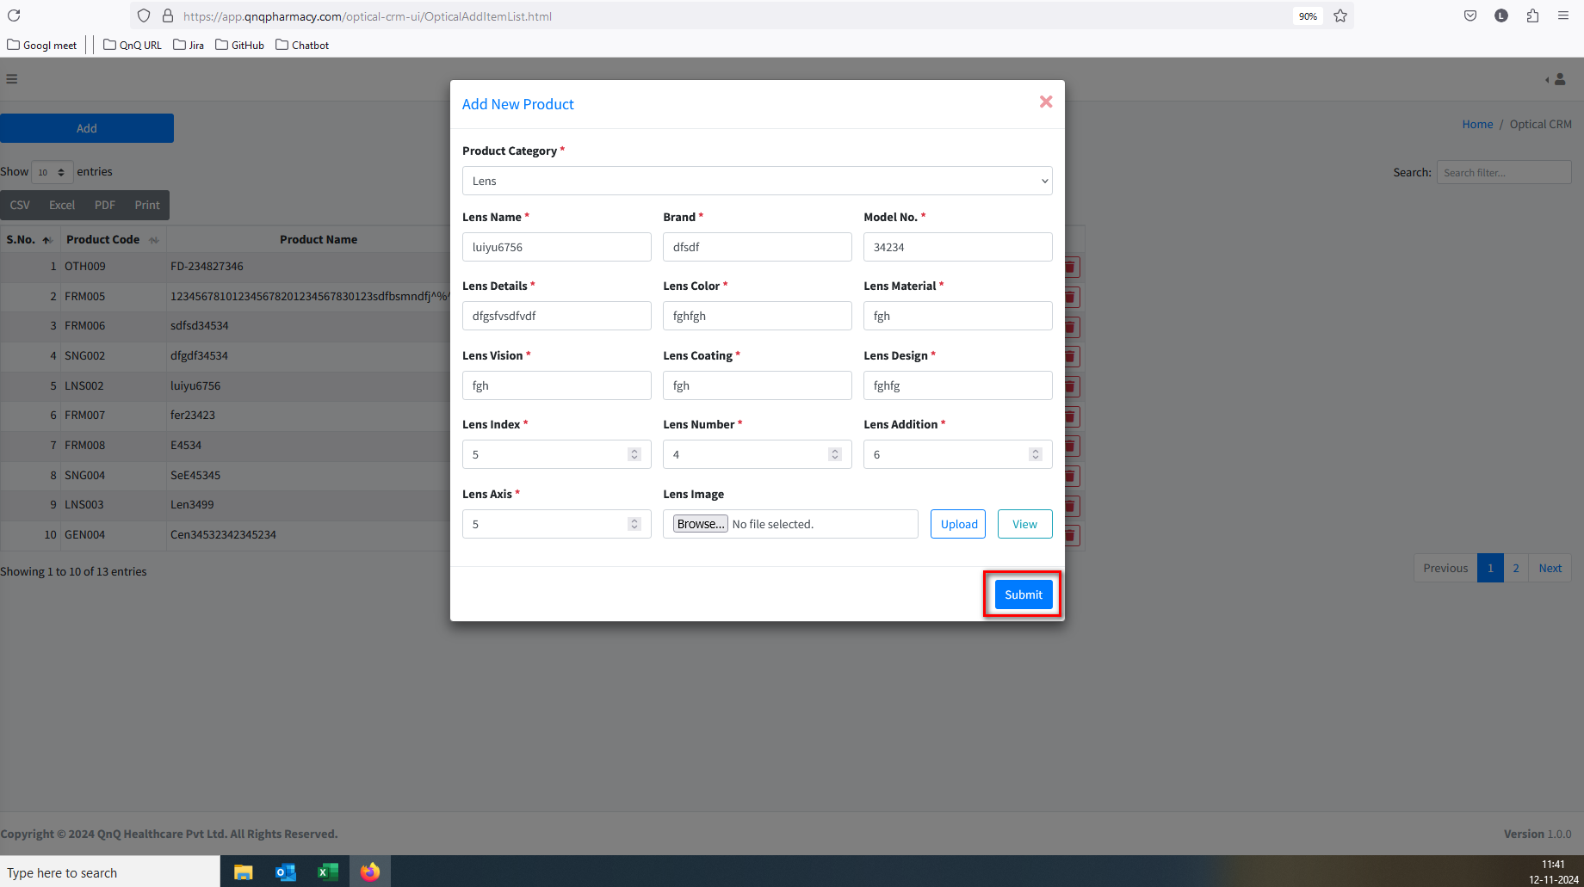//
49. Edit or New batch mode not display in Pop up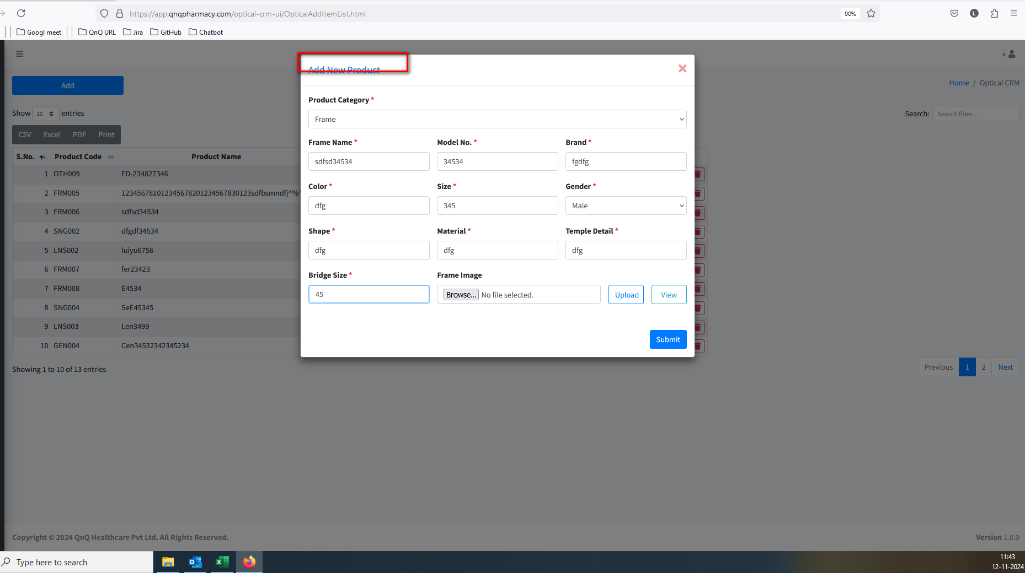//
50. Unwanted content display in all dropdown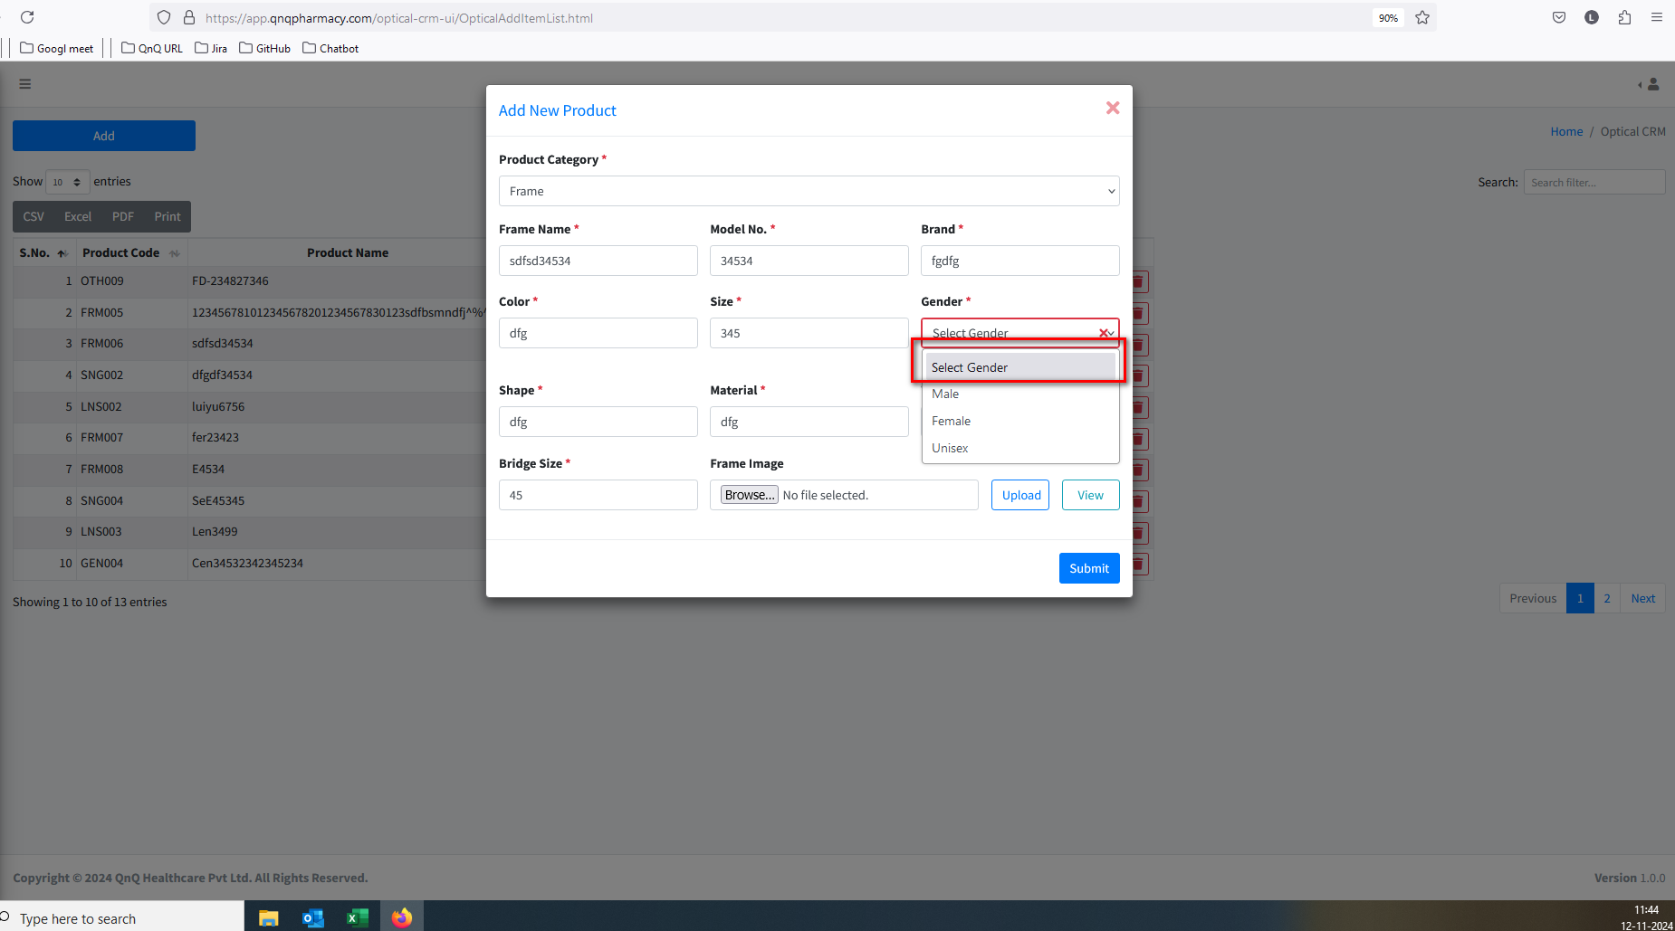//
51. Unwanted Print button display in list grid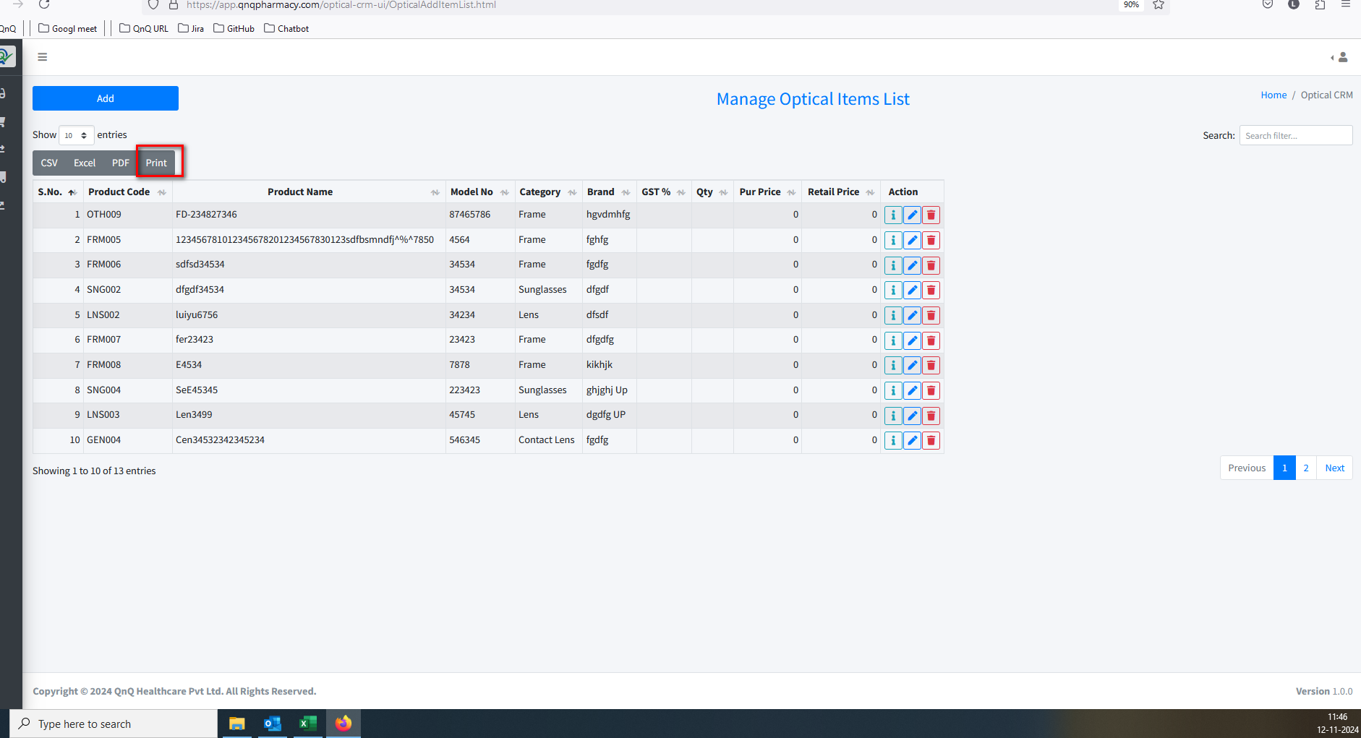//
52. Mismatch File name display in the download file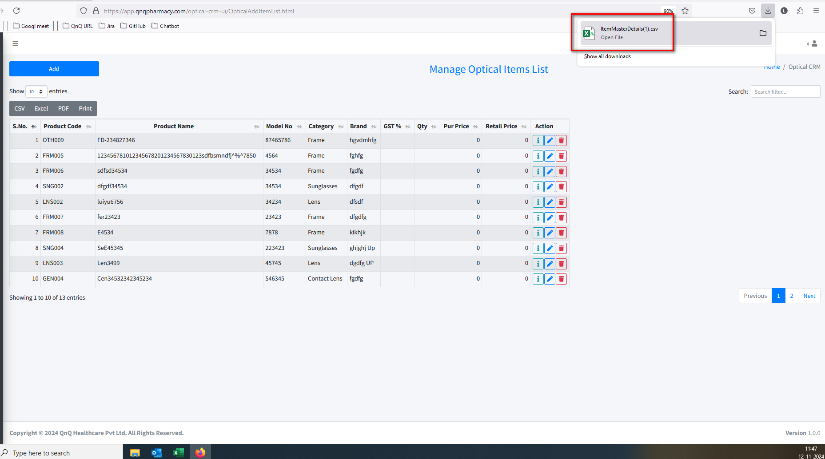//
53. Unwanted error message display while open the CSV file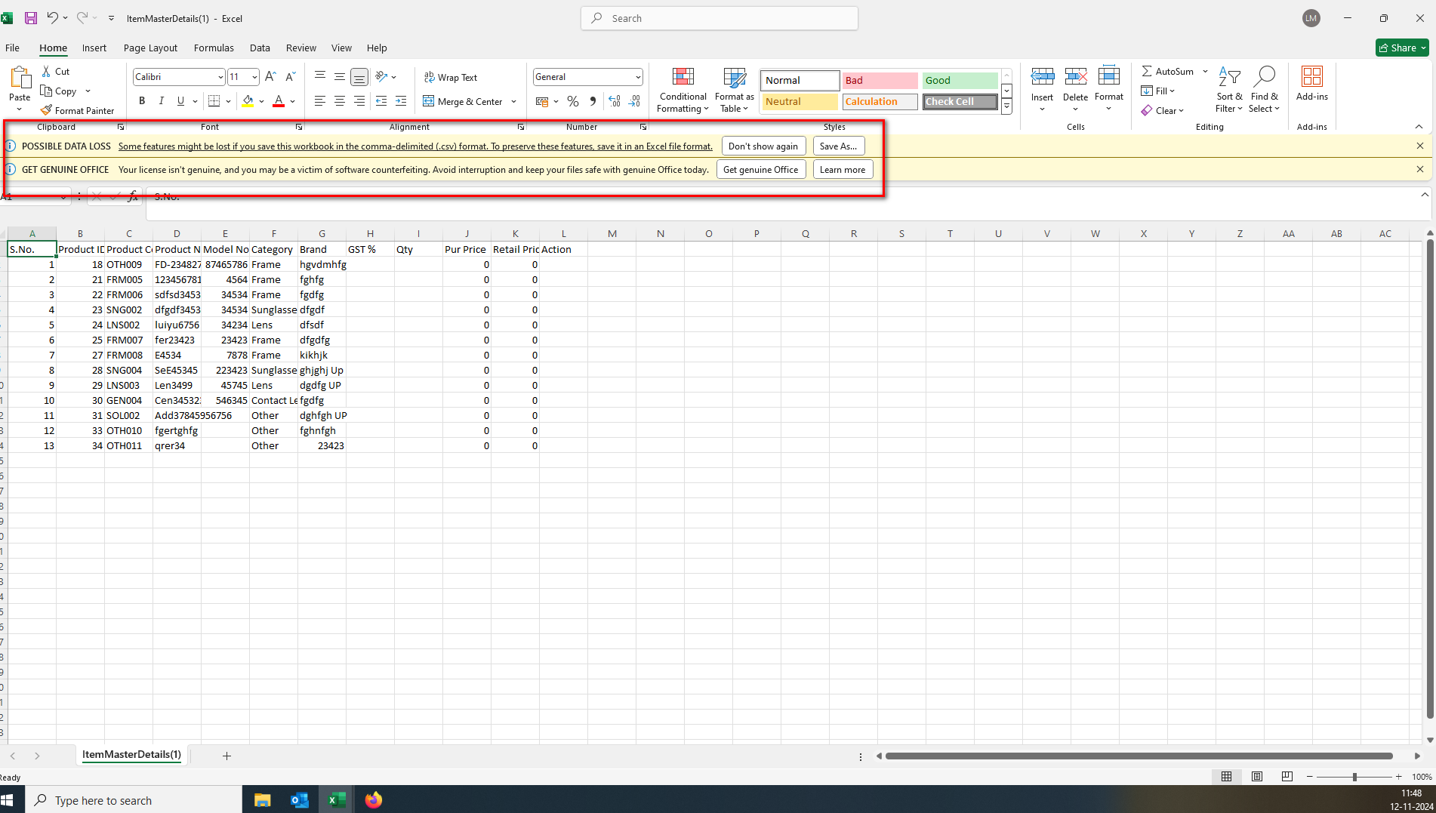//
54. Unwanted column display in download file in CSV file 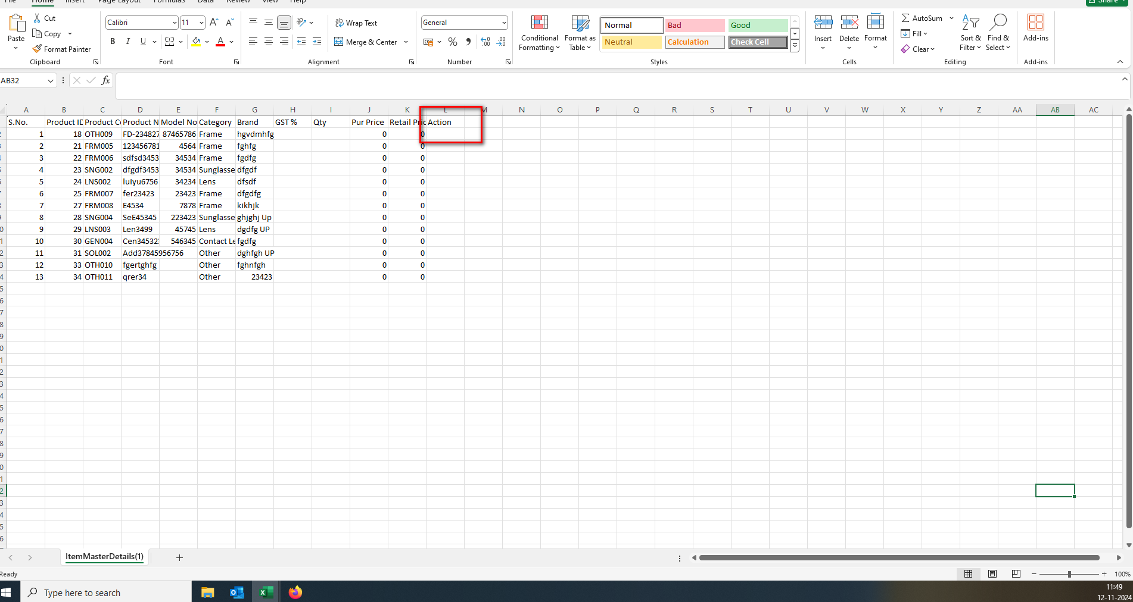//
55. The column header does not appear like the ad header column in CSV file 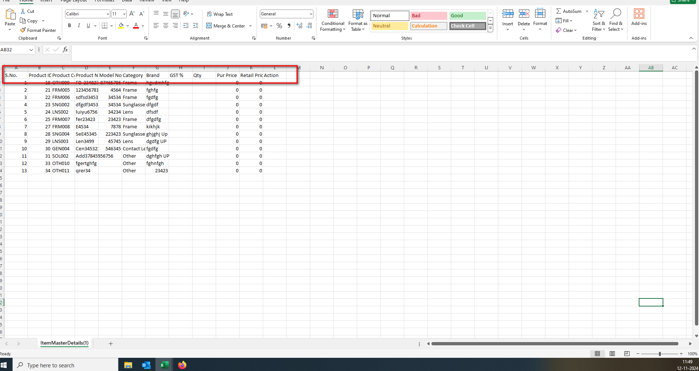 //
56. The sheet name appears without spaces in CSV file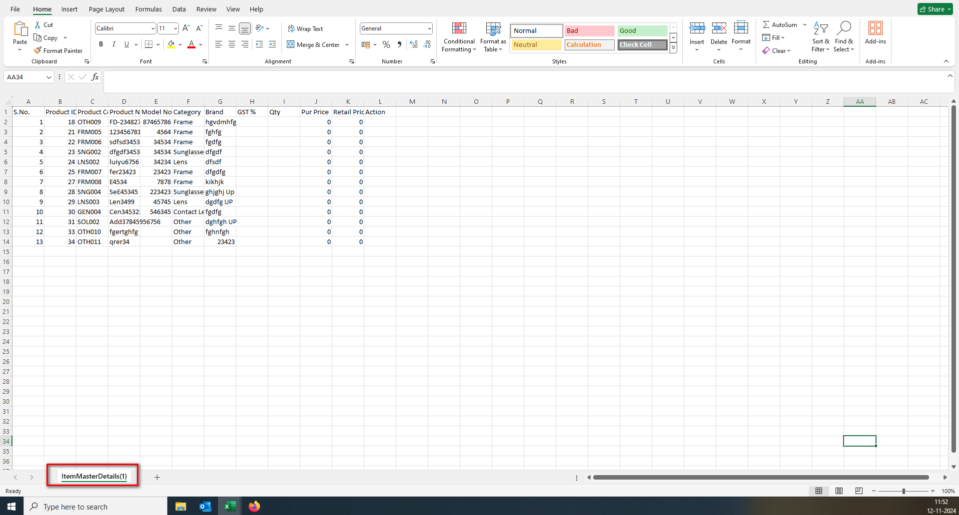 //
57. Document Title not display in excel file 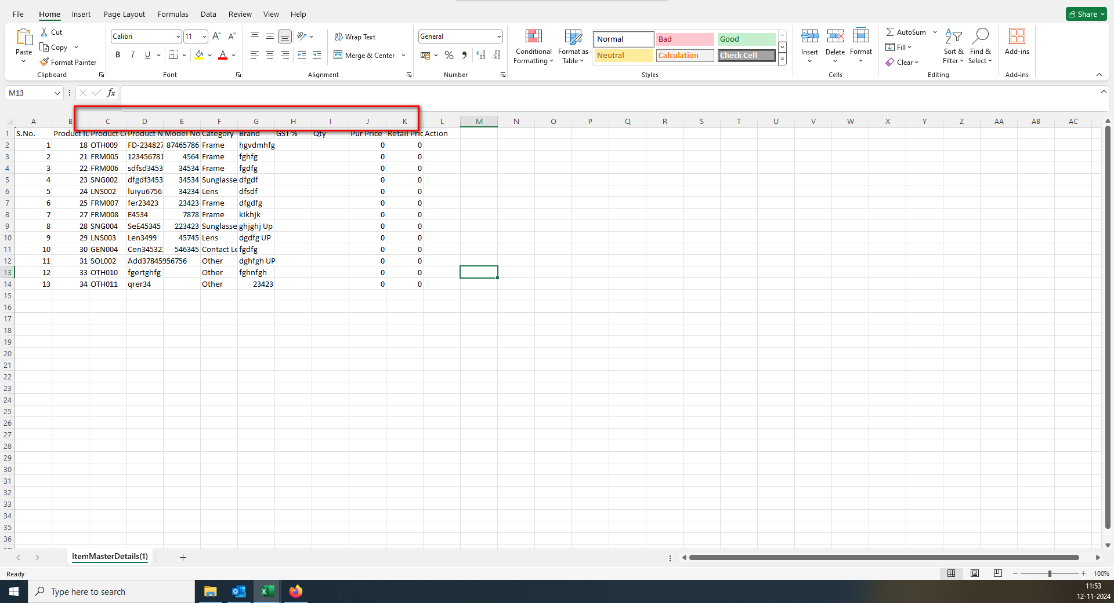 //
58. Sheet name not display in excel file  //
59. The data is not displaying correctly; some of it is getting lost 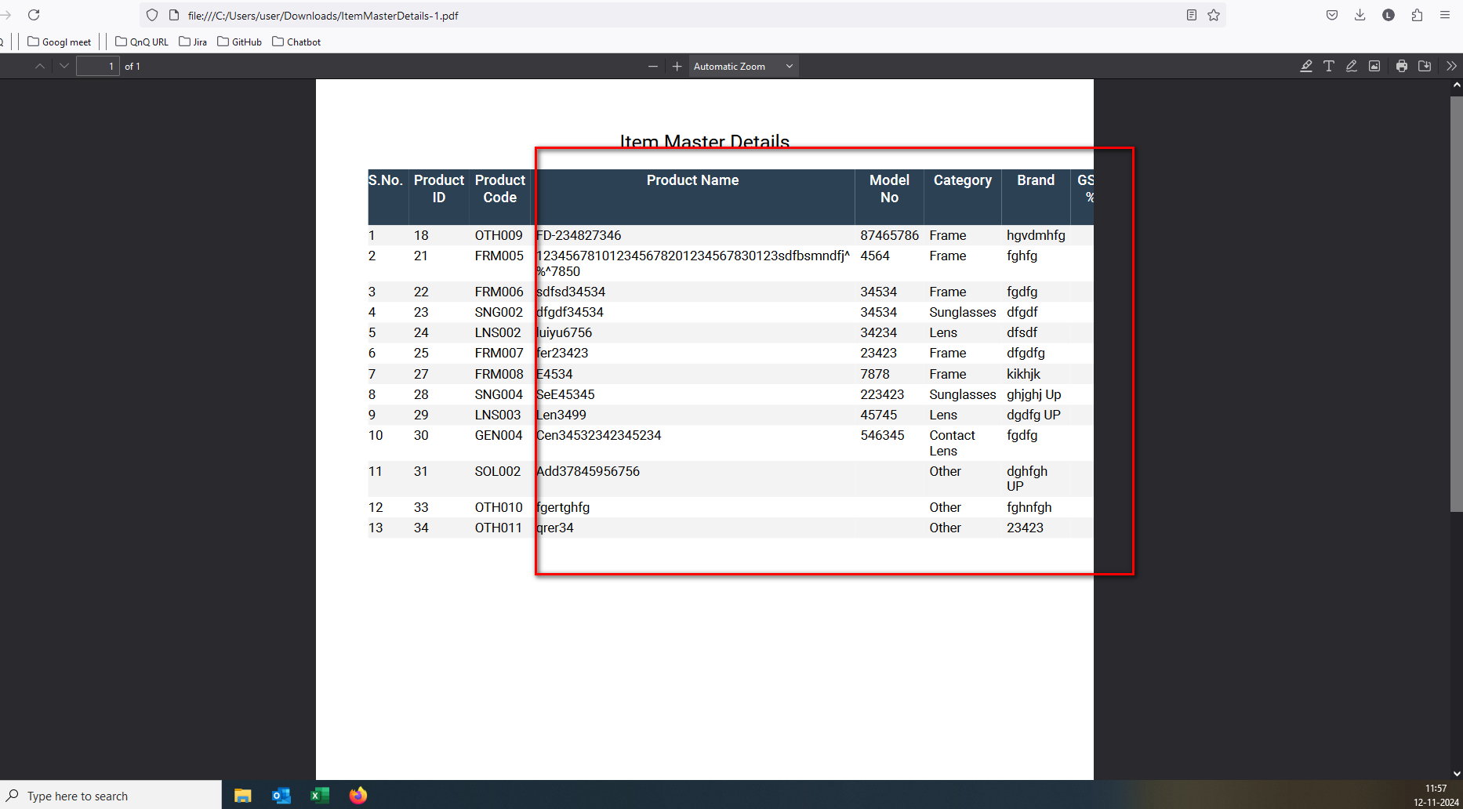 //
60. Mismatch Title name display in Delete confirmation pop up 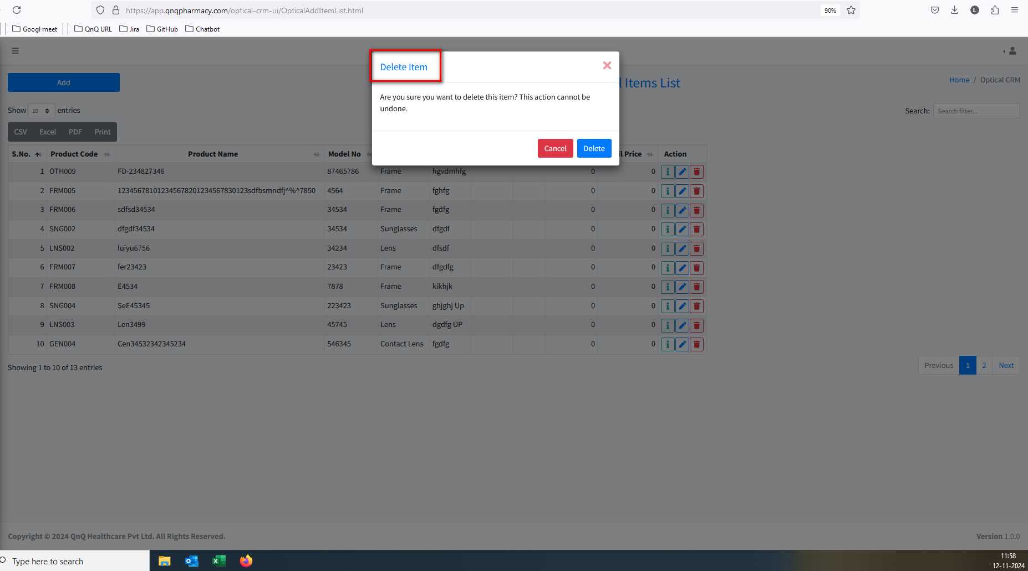 //
61. The system allows file uploads even when the title exceeds 50 characters 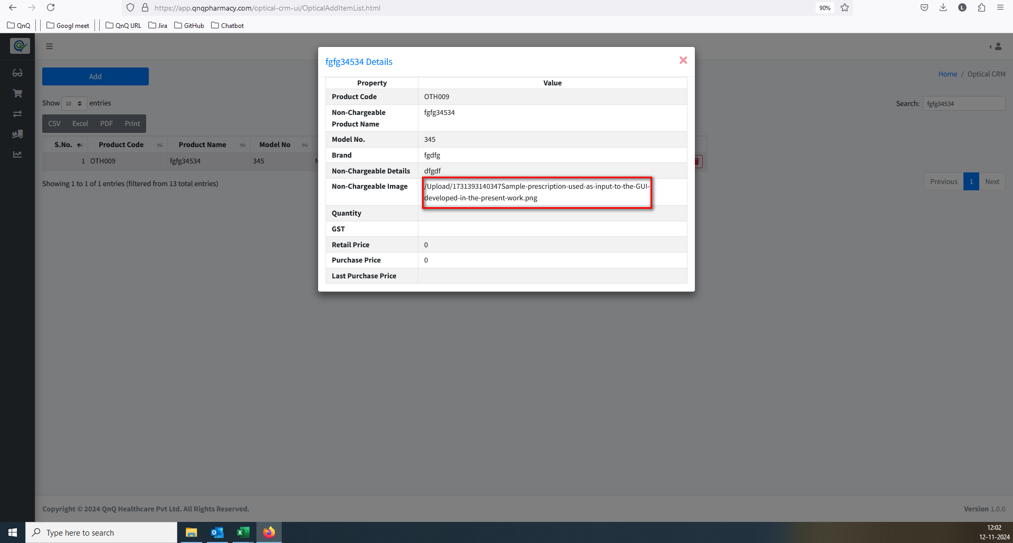 //
62. There is no indication or message showing the format type of the file being uploaded in the upload section  